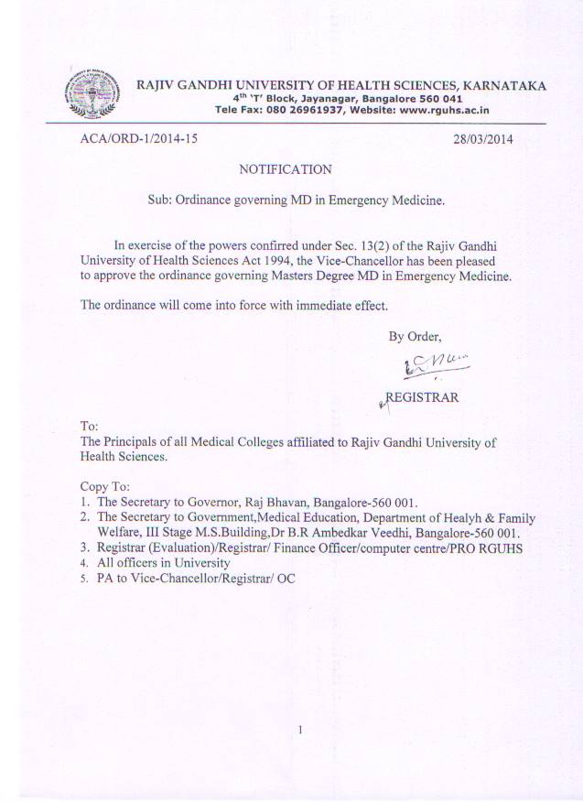

Syllabus – MD Emergency Medicine
Clinical skills for MD - Emergency Medicine
- Clinical history taking and examination; ability to analyze different clinical symptoms and signs; interpret their significance
- Interpretation of laboratory data
- Interpretation of pulmonary function tests, ECG, ECHO and other investigations
- Interpretation of chest roentgenography
- Oxygen therapy
- Nebulisation therapy
- Mechanical ventilation – indications and applications
SYLLABUS - ACCIDENT AND EMERGENCY MEDICINE

The orientation of training in Accident & Emergency Medicine shall encompass the following:

A Principles of Emergency Care – Patient centred

- Organisational issues and quality standards
- Resuscitation, recognition of threats to life/limb
- Triage of the emergency department patient
- Understanding of "timeliness" and documentation
- Therapeutics and pain control
- Patient dignity and privacy
- Ethical issues and confidentiality
Training is based on the acquisition of knowledge, skills and professional attributes and can be broadly outlined as follows:
I Cardiovascular Diseases
A Cardiopulmonary Resuscitation

- One and two-rescuer CPR
- Choking victim
- Adult/Child/Infant CPR

B Advanced Cardiac Life Support (certification is expected)

- Recognition of ventricular fibrillation/ventricular tachycardia/asystole / pulseless electrical activity/bradyarrhythmias
- Protocols drugs and pacing
- Resuscitation team leadership

C Cardiac Chest pain

- Acute coronary syndromes (Angina pectoris, myocardial infarction)
- Thrombolysis, glycoprotein inhibitors, angioplasty
- Pulmonary embolism
- Aortic dissection

D Heart failure and pulmonary oedema

E Narrow/Broad complex tachycardias

F Hypertensive emergencies

G Cardiac pacemaker function/failure

H Peripheral vascular disease

II Trauma

A Advanced Trauma Life Support (certification is expected)

- Primary survey/resuscitation
- Secondary survey
- Definitive care
- Transfer arrangements

B Head and facial trauma

C Chest and cardiac trauma

- Blunt/penetrating
- Tension pneumothorax
- Cardiac tamponade
- Massive haemothorax
- Open chest wound
- Ruptured aorta
- Blast injury
- Flail chest/lung contusion

D Abdominal trauma

- Blunt/penetrating
- Special investigations (DPL, US, CT)

E Genito-urinary trauma

F Extremity trauma

- Hand injuries
- Skeletal trauma
- Vascular trauma
- Soft tissue injury

G Spinal trauma - Immobilisation/Extrication/Logrolling techniques

H Paediatric trauma

I Trauma in pregnancy

J Trauma in the elderly

III Anaesthesia

A Principles of airway management

B Rapid sequence induction

C Pain relief

D General, regional, local anaesthesia

E Interface with Intensive Care

IV Shock

A Clinical findings and differential diagnosis

B Fluid resuscitation

C Blood/blood products

V Pulmonary Emergencies
A A Acute respiratory failure
B Asthma
C Chronic obstructive airways disease
D Foreign body

E Pneumothorax

F Chest infection

G Thermal/chemical injury

H Evaluation of dyspnoea

I Haemoptysis

VI Gastrointestinal Conditions

A Acute GI bleed

B Vomiting, diarrhoea, dehydration

C Abdominal pain evaluation

D Foreign body ingestion

VII Ophthalmology

A The red eye

Conjunctivitis
Acute glaucoma

Uveitis

B Trauma

- Foreign Body/corneal abrasion
- Chemical burns
- Hyphaema and blow-out fracture

C Causes of visual impairment

D Orbital cellulitis

VIII Metabolic Emergencies

A Hypoglycaemia

B Ketoacidosis / Hyperosmolar coma

C Electrolyte abnormalities

D Acid-base abnormalities

IX Gynaecology & Obstetrics

A Ectopic pregnancy

B Pelvic inflammatory disease/lower abdominal pain

C Antenatal bleeding/Miscarriage

D Pre-eclampsia / Eclampsia

X Genito-urinary Medicine

A Sexually transmitted diseases

B Epididymitis / Orchitis / Prostatitis

C Testicular torsion

D Sexual assault

E Nephrolithiasis

F Urinary Tract Infections

G Haematuria

XI Infectious Diseases

A Hepatitis

B HIV/AIDS

C Tuberculosis

D Malaria

E Childhood illnesses

F Pyrexia of undetermined origin

G Herpes

H Needlestick injury

XII Toxicological emergencies

A Recognition of clinical syndromes

B Initial treatment of poisoning

C Agent-specific therapy

D Role of poison centres/databases

E Decontamination facilities/procedures (including radio-activity)

XIII Childhood Emergencies

A Advanced Paediatric Life Support (certification is expected)

B Developmental paediatrics

C Croup/epiglottitis

D Asthma

E Fever

F Dehydration/gastrointestinal disorders

G Meningitis/septicaemia

H Seizures

I Congenital/inherited illness

J Pain relief

K Parasuicide in adolescents

L Non-accidental injury and child sexual abuse

M Common injuries

N Surgical emergencies

O Urinary tract infections

P Links with community care (GP, HV, social services)

XIV Environmental Emergencies

A Burns

- Grading/resuscitation
- Smoke inhalation
- Outpatient treatment

B Heat illness

C Hypothermia

D Near drowning

E Electrical injury (including lightning)

F Bites

- Snake/dog/cat/human/arthropod
- Rabies/tetanus prophylaxis

G Anaphylaxis

XV ENT Conditions

A Upper airway obstruction

B Epistaxis / septal haematoma

C Foreign bodies

D Infections

XVI Neurological Emergencies

A Coma

B Headache / Subarachnoid haemorrhage

C Meningitis

D Seizures

E Stroke

F Collapse

XVII Musculo-Skeletal Conditions

A Orthopaedic & neurovascular extremity examination

B Strains/sprains/fractures

C Dislocations

D Septic joint

E Soft tissue injury/infection

F Compartment syndrome

G Back pain

H Rheumatological disorders

XVIII Behavioural Emergencies

A Mental state examination

B Organic illness manifest as behavioural disorders

C Acute psychosis

D Deliberate Self-Harm

Suicidal and homicidal evaluation

F Drug and alcohol misuse

XIX Geriatric Emergencies

A Psycho-social assessment

B Mental state examination

C Mobility assessment

D Multi-system pathology

XX Maxillo-facial conditions

A Dental emergencies

B Facial fractures/dislocations

XXI Dermatology

A Common rashes

B Atopy

XXII Social Emergencies

A Overall care of the patient

B Frequent attenders

C Homelessness

D Hospital hopper / Munchausen’s

XXI Haematological Emergencies

A Haemoglobinopathies

B Haemophilia

XXII Legislation/Statutory Circulars

A Consent, competence and confidentiality

B Children Act

C Mental Health Act

D Health and Safety at Work Act

E Road Traffic Act

F Data Protection Act

G Access to Health Records Act

H Patients' Charter

I NHS and Community Care Act

J Role of the Coroner

K Organ/Tissue Donation

L Hospital Complaint Procedure Act

M Equal Opportunities

N Human Rights Act

O Good Medical Practice

CLINICAL SKILLS

I Wound Management

A Types of wounds/extremity examination

B Wound preparation

C Wound closure techniques

D Foreign bodies

E Extensor tendon repair

F Incision of abscesses and pulp space infections

G Flexor tendon sheath infections (including palmar spaces)

H Finger tip injuries

I Dressing techniques

J Plaster and immobilisation techniques

K Joint aspiration, soft tissue injection

L Anaesthetic techniques

II Cardiopulmonary Resuscitation Training

A Cardioversion/Carotid sinus massage

B ECG interpretation

III Major Trauma Management and team leader function

IV Airway (C-spine control)

A Basic airway management

B Advanced airway management (tracheal intubation/alternatives)

C Surgical airway

V Breathing

A Needle/tube thoracostomy

B Ventilation techniques (including noninvasive)

VI Circulation

A Central venous access

B Arterial access

C Cut down techniques

D Femoral vessel cannulation

E Pericardiocentesis

F Intra-osseous access

G CVP monitoring

VII Splinting/Immobilisation

A Spinal immobilisation

B Limb splinting/Traction splints

C Logrolling
VIII ENT

A Indirect laryngoscopy

B Nasal packing

IX Maxillo-facial

A Dental anaesthesia

B Dental socket suture

C Plastic surgery techniques

X Reduction of Fractures/Dislocations (Local and regional anaesthetic Techniques/pain relief)

XI Gastric Lavage/Activated charcoal

XII Slit Lamp

XIII Interpretation of laboratory investigations

XIV Imaging interpretation (Ultrasound/CT/MRI included)

XV Transportation of Patients

COMMUNICATION SKILLS

I Professional Relationships

A Patients and relatives
B Colleagues/team working
C Other staff

II Consultation Skills

II Record keeping

III Bereavement Care

A Breaking bad news

B Referral for counselling

MANAGERIAL SKILLS

I Policies/procedures ( Hospital, Departmental)

II Staff management (planning, recruitment, appraisal)

III Equipment (choosing to ordering, medical physics)

IV Resource management/clinical budgeting

V Contracting/standards setting, quality monitoring

VI Information technology/Health informatics

VII Clinical governance/audit, risk management

VIII Compliments/complaints

IX Medico-legal statements/Woolfe reforms

X Committee Work

XI Liaising with other agencies (e.g. police, coroner)

XII Public Relations/media

XIII Major Incident planning/exercises

TEACHING SKILLS

I Lecture preparation

II Small Group techniques

III Presentation techniques

IV Teaching critique

V Departmental teaching programme

VI Professional Development (self-directed learning)

VII Teaching certificate expected

RESEARCH SKILLS

I Literature survey

II Scientific study design

III Data evaluation/Statistics

IV Preparing publications

PROFESSIONAL ATTRIBUTES

I Leadership

II Reliability

III Teamwork

IV Self-motivation (prioritisation, project completion)

