Conditions:
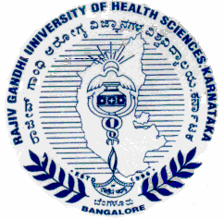
PassgÁfÃªï UÁA¢ü DgÉÆÃUÀå «±Àé«zÁå®AiÀÄ, PÀ£ÁðlPÀ
4£ÉÃ n ¨ÁèPï, dAiÀÄ£ÀUÀgÀ, ¨ÉAUÀ¼ÀÆgÀÄ – 560 041.
RAJIV GANDHI UNIVERSITY OF HEALTH SCIENCE, KARNATAKA
4TH ‘T’ Block, Jayanagar, Bangalore – 560 041.
Tel : 080-26961928

RGU/NRI/M.Pharma/2767/12-13 Date: 25-11-2013

CIRCULAR

In continuation of circular No.RGUHS/SWF/Misc-07/G-Cir/2012-13 dated 12-07-2012, it is once again reminded to all concerned that the applications for eligibility certificate received six months later than the last date of submission as prescribed in the calendar of events , will be strictly rejected. It is also noted that many applications are received without the required fee and/or required documents. In these cases, the date of fulfilling all the deficiencies/ requirements shall be taken as the actual date of submission of application for eligibility certificate. Calculation of the ‘late submission fees’ or rejection of application due to delay of more than six months, shall be on the basis of actual date of completing all the requirements of application.

Sd/-
(Dr.D.Prem Kumar),
Registrar.
To the Principals of all affiliated colleges of the University.

