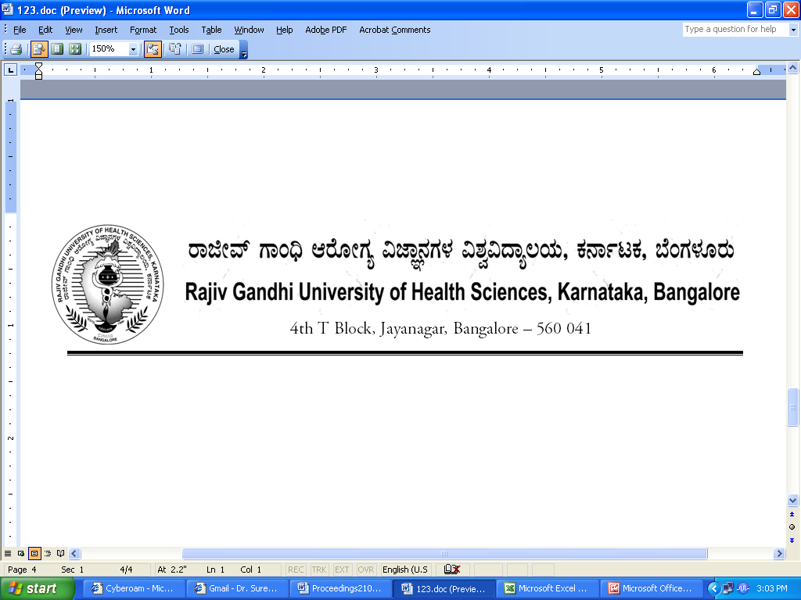
AUTH/100 SYN/RT/251/2012-13 29/09/2012

NOTIFICATION

Sub: | Approval of Revised Curriculum in the subject of Radiation Physics of II and III Year of B.Sc. Radiation Therapy Technology
Ref:1) | Minutes of the meeting of Board of Studies in Allied Health Sciences held on 15.06.2012
2) | Recommendations of Committee of Academic Council in its meeting held on 27.08.2012
3) | Minutes of 100th meeting of Syndicate held on 28/08/2012.

In exercise of the powers conferred by Section 35(2) of RGUHS Act 1994, the Syndicate in its 100th meting held on 28/08/2012 is pleased to notify the Revised Curriculum in the subject of Radiation Physics of II and III Year of B.Sc. Radiation Therapy Technology as shown in the annexure appended herewith.
The Ordinance shall come into force from the academic year 2012-13.
By Order,
Sd/-
(Dr.D.Prem Kumar)
REGISTRAR

To:

The Principals of colleges affiliated to RGUHS
conducting B.Sc. Radiation Therapy course

Copy to:
- The Principal Secretary to Governor, Governor’s Secretariat, Raj Bhavan, Bangalore – 560 001.
- Principal Secretary to Government, Health & Family Welfare Department, (Medical Education), Vikasa Soudha, Bangalore –560 001.
- The Director, Department of Medical Education, Anand Rao Circle, Bangalore – 560 009.
- PA to Vice-Chancellor / Registrar / Registrar (Eva.) / Finance Officer.
- Director, Curriculum Development Cell.
- The Home Page of RGUHS Website – http://www.rguhs.ac.in/Authoritysection/Fellowship.html.
- Guard File / Office Copy.

