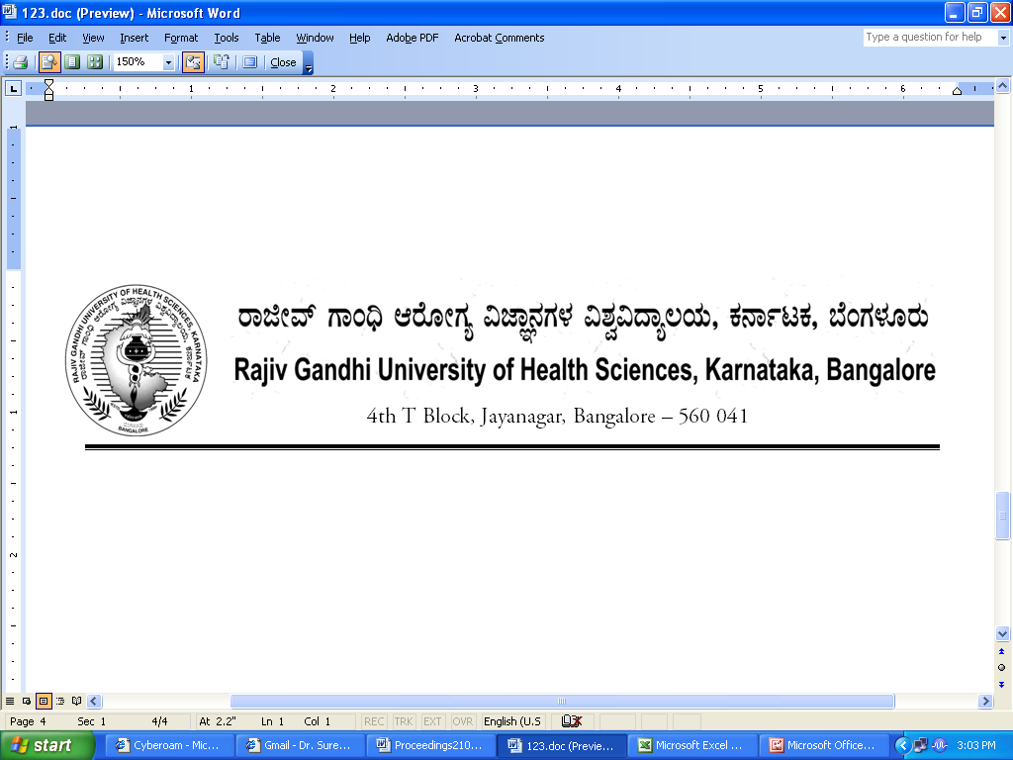

AUTH/AHS/264/2012-13 29/09/2012

AMENDMENT TO NOTIFICATION
Sub : | Amendment to the Ordinance pertaining to the Regulations and Curriculum for Bachelors of Science Degree in Allied Health Sciences.
Ref:1) | RGUHS Notification No. AUTH/AHS/317/2008-09, dated:01/08/2008 and 16/08/2011
2) | Minutes of meeting of BOS in Allied Sciences held on 15/06/2012
3) | Minutes of meeting of Academic Council held on 27/08/2012
4) | Minutes of the 100th Meeting of the Syndicate held on 28/08/2012

In exercise of the powers conferred under Section 35(2) of RGUHS Act, 1994, the Syndicate is pleased to notify the amendment to the Ordinance of Regulations and Curriculum for Bachelor of Science Degree Courses in Allied Health Science pertaining to eligibility for admission of candidates to Allied Heath Science courses.

EXISTING | REVISED
5. Candidates who have passed diploma from a Government Board or a Government recognized board in Allied Health Science/Health Science subjects shall be eligible to join the first year of the Bachelors in any Allied Health Sciences provided they are not eligible for the lateral entry scheme details of which are mentioned below. Please note that Diploma programs conducted by Para Medical Board, Directorate of Medical Education, Government of Karnataka shall be eligible to join the first year in any allied health science bachelors programs conducted by RGUHS. | 5(a) Candidates who have passed diploma from a Government Board or a Government recognized board in Allied Health Science/Health Science subjects shall be eligible to join the first year of the Bachelors in any Allied Health Sciences provided they are not eligible for the lateral entry scheme details of which are mentioned below. Please note that Diploma programs conducted by Para Medical Board, Directorate of Medical Education, Government of Karnataka shall be eligible to join the first year in any allied health science bachelors programs conducted by RGUHS.  5(b) Candidates who have passed 10+2(PUC or equivalent examination) in Arts, Commerce shall be eligible to join first year in any Allied Health Science Bachelor programs.  It is mandatory for candidates who have not studied Physics, Chemistry and Biology during their Pre University/ +2 /HSC should undergo special classes ( Number of hours: Physics 40 hours, Chemistry 40 hours & Biology 40 hours) for the said subjects. Following these special classes, they will have to undergo MCQ examination of 100 marks for each subject respectively conducted by the University at the end of 6 months. Only those candidates who clear these examinations successfully getting a minimum of 50%in each subject respectively shall be eligible to appear for the 1st year annual examination conducted by the university. Those candidates who fail to secure a minimum of 50% shall be given a chance for appearing for a repeat test within 1 month from the date of first examination. Candidates who have not cleared this second examination by securing minimum 50% marks in each subject shall not be eligible to appear for the 1st year university examinations and shall appear for the MCQ Test again after 6 months. Only after clearing the MCQ test the candidate shall be eligible to appear for the 1st year University examinations. A candidate shall have a maximum of 4 attempts for the MCQ test failing which the candidate would have to discontinue the course.  ….2  - 2 -  NOTE: Those students who wish to apply for the Bachelors in Imaging Technology or B.Sc in Radiation Therapy should have compulsorily studied Mathematics as one of the main subject.
The above Amendment to Ordinance shall be applicable from the academic year 2012-13 and onwards.

By Order,

Sd/-
REGISTRAR
To,

The Principals of colleges conducting Allied Health Sciences affiliated to RGUHS.

Copy to:
- The Secretary to Governor, Governor’s Secretariat, Raj Bhavan, Bangalore - 560 001.
- The Principal Secretary to Government, Health & Family Welfare Department, (Medical Education), Vikasa Soudha, Bangalore – 560 001.
- The Members of the Syndicate of RGUHS.
- PA to Vice-Chancellor/Registrar/Registrar (Evaluation)/Finance Officer, RGUHS, B’lore.
- Guard file/Office copy.

