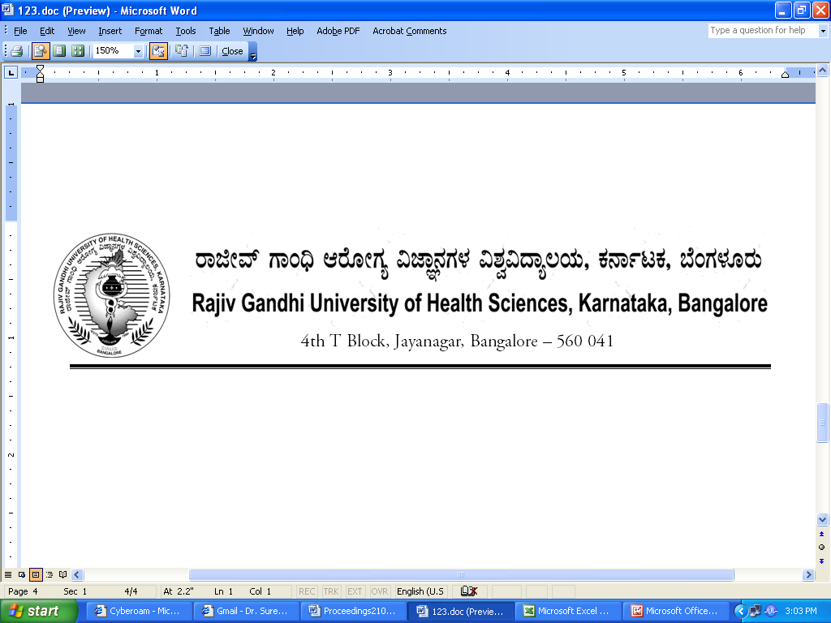
AUTH/99 SYN/Amend/BAMS/204/2012-13 15/12/2012

NOTIFICATION

Sub: | Amendment to Revised Ordinance governing BAMS degree course and curriculum – 2009.
Ref:1) | RGUHS Notification No.UA/ORD-6/2000-2001, dated:19/06/2006 regarding amendment to revised ordinance governing BAMS course.
2) | RGUHS Notification No.UA/AUTH/ORD6/Amend-2/2000-01, dated: 12/06/2011.
3) | RGUHS Notification No.AUTH/ORD 6/Amend-2/2000-2001, dated:09/12/2011 regarding amendment to revised ordinance governing BAMS degree course.
4) | Orders of Hon’ble High Court of Karnataka in W.P.Nos. 48533, 49326, 50107, 50109/12 etc., dated: 12/12/2012.
5) | Orders of Hon’ble Vice-Chancellor dated: 14/12/2012.

In exercise of the powers conferred by Section 13(2) of Rajiv Gandhi University of Health Sciences Act 1994, Hon’ble Vice-Chancellor on the basis of the orders of Hon’ble High Court of Karnataka dated 12/12/2012 in W.P.No.48533, 49326, 50107, 50109/12 etc., is pleased to notify the amendment to Revised Ordinance governing BAMS Degree course and curriculum 2009 as shown below.

Existing | Amended
Candidate who fails to pass the first Professional examination in three opportunities shall not be allowed to continue their studies. However, in case of personal illness of a serious nature of a candidate and in unavoidable conditions/circumstances, the Vice-Chancellor of University may permit one more opportunity for passing the first professional course | The candidates who have failed to pass First Professional BAMS Examination in three or more opportunities are given final chance to appear for December 2012 examination of First Professional BAMS Degree course.

The above Ordinance shall come into force with immediate effect.

By Order,

Sd/-
REGISTRAR
To:
All the Principals of Ayurvedic Medical colleges affiliated to RGUHS.

Copy to:

- The Secretary to Governor, Governor’s Secretariat, Raj Bhavan, Bangalore – 560 001.
- The Principal Secretary to Government, Health & Family Welfare Department, (Medical Education), Vidhana Soudha, Bangalore –560 001.
- The Director, Department of AYUSH, Government of Karnataka, Dhanvanthri Road Bangalore-560009.
- PA to Vice-Chancellor / Registrar / Registrar (Eva.) / Finance Officer.
- The Director, Curriculum Development Cell.
- The Home Page of RGUHS Website http://www.rguhs.ac.in/Authoritysection/Fellowship.html.
- Guard File / Office Copy.

