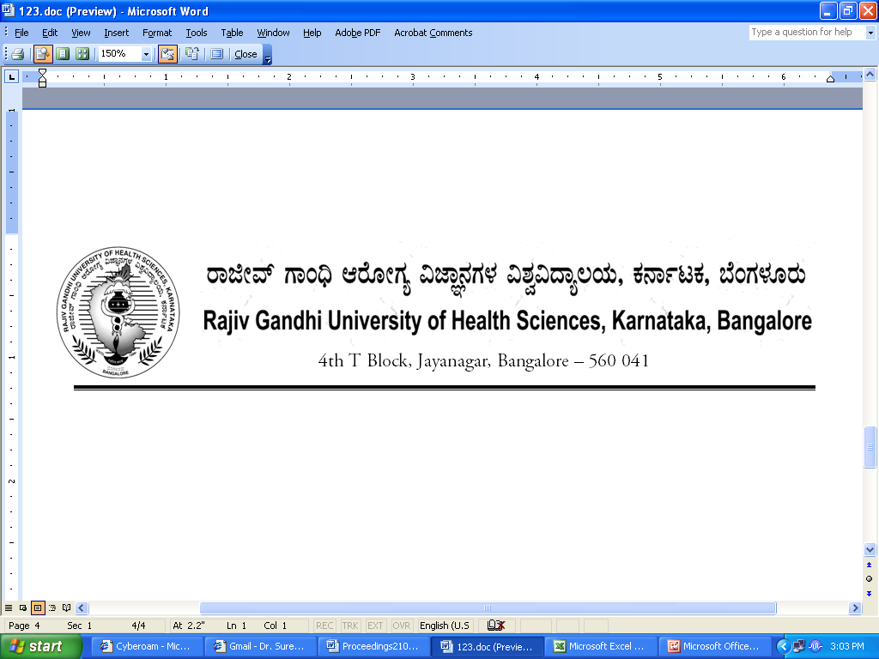
AUTH/100 SYN/M.Sc.MLT/248/2012-13 29/09/2012

NOTIFICATION

Sub: | Approval of Revised Curriculum for M.Sc.MLT
Ref:1) | RGUHS Notification No. UA/SYN/ORD-M.Sc.MLT/38/2006-07 dated 02.04.2007
2) | Minutes of the meeting of Board of Studies in Allied Health Sciences held on 15.06.2012
3) | Recommendations of Committee of Academic Council in its meeting held on 27.08.2012
4) | Minutes of 100th meeting of Syndicate held on 28/08/2012.

In exercise of the powers conferred by Section 35(2) of RGUHS Act 1994, the Syndicate in its 100th meting held on 28/08/2012 is pleased to notify the Revised Curriculum for M.Sc. MLT as shown in the annexure appended herewith.

The Ordinance shall come into force from the academic year 2012-13.
By Order,
Sd/-
(Dr.D.Prem Kumar)
REGISTRAR
To:
The Principals of colleges affiliated to RGUHS
conducting M.Sc. MLT course

Copy to:
- The Principal Secretary to Governor, Governor’s Secretariat, Raj Bhavan, Bangalore – 560 001.
- Principal Secretary to Government, Health & Family Welfare Department, (Medical Education), Vikasa Soudha, Bangalore –560 001.
- The Director, Department of Medical Education, Anand Rao Circle, Bangalore – 560 009.
- PA to Vice-Chancellor / Registrar / Registrar (Eva.) / Finance Officer.
- Director, Curriculum Development Cell.
- The Home Page of RGUHS Website – http://www.rguhs.ac.in/Authoritysection/Fellowship.html.
- Guard File / Office Copy.

