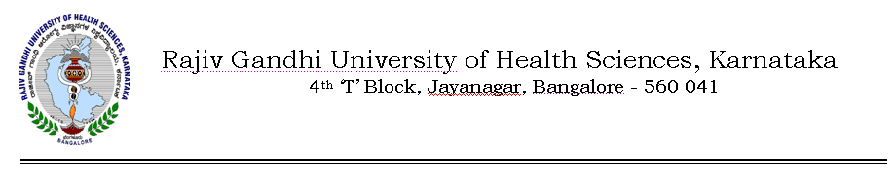
Auth/99 SYN/Admission/BDS/MBBS/206/2012-13 14/06/2012

NOTIFICATION

Sub: | Approval of Admission of students who have taken admission to 1st BDS/MBBS courses without taking any of the Entrance Tests conducted by All India/CET/COMEDK/KRLM Association for the year 2011-12
Ref: | Minutes of the meeting of the Syndicate held on 11/06/2012.

In exercise of the powers conferred under section 35(1) of Rajiv Gandhi University of Health Sciences Act 1994, the Syndicate in its 99th meeting held on 11/06/2012 approved the admissions of all the candidates who have taken admission to 1st BDS/MBBS courses without taking any of the Entrance Tests conducted by All India/CET/COMEDK/KRLM Association for the year 2011-12 as one time measure.

The above ordinance shall come in to force with immediate effect for the batch of the students admitted for the academic year 2011-12

By Order,
Sd/-
(Dr.D. Prem Kumar)
REGISTRAR
To

1. The Registrar(Evaluation)/ Deputy Registrar(Admissions),RGUHS Bangalore
2. The Principals of all Medical and Dental Colleges affiliated to RGUHS.

Copy to:
- The Secretary to Governor, Governor’s Secretariat, Raj Bhavan, Bangalore – 560 001.
- The Principal Secretary to Government, Health & Family Welfare Department, (Medical Education), Vidhana Soudha, Bangalore –560 001.
- The Director, Department of Medical Education, Anand Rao Circle, Bangalore – 560 009.
- PA to Vice-Chancellor / Registrar / Registrar (Eva.) / Finance Officer.
- Director, Curriculum Development Cell.
- Public Information Officer.
- The Home Page of RGUHS Website http://www.rguhs.ac.in/Authoritysection/Fellowship.html.
- Guard File / Office Copy.

