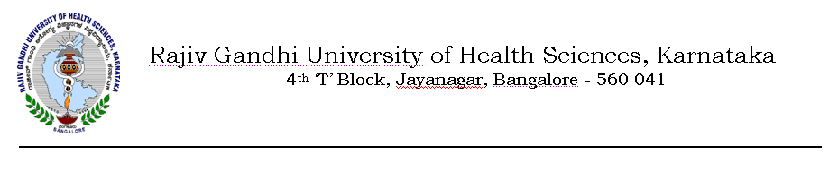Auth/99 SYN/Amend/BAMS/204/2012-13 14/06/2012
NOTIFICATION

Sub: | Amendment to Revised Ordinance governing BAMS degree course and Curriculum - 2009
Ref: 1) | RGUHS Notification No.UA/ORD-6/2000-2001, dated 19/06/2006 regarding amendment to revised ordinance governing BAMS course
2) | RGUHS Notification No.AUTH/ORD 6/Amend-2/2000-2001 dated 09/12/2011 regarding amendment to revised ordinance governing BAMS degree course
3) | Representations of Students, Faculty and Association of Ayurvedic Medical Colleges to University
4) | Minutes of the meeting of the Syndicate held on 11/06/2012.

In exercise of the powers conferred under section 35(1) of Rajiv Gandhi University of Health Sciences Act 1994, the Syndicate in its 99th meeting held on 11/06/2012 is pleased to notify the amendment to Ordinance governing Revised BAMS Course and Curriculum – 2009 as shown below:
Existing | Amended
9.3(v)  Candidate who fails to pass the first Professional examination in three opportunities shall not be allowed to continue their studies. However, in case of personal illness of a serious nature of a candidate and in unavoidable conditions. circumstances, the Vice-Chancellor of University may permit one more opportunity for passing the first professional course | 9.3(v)  All the candidates who have failed to pass First Professional BAMS Examination in three or more opportunities are given one more chance to appear for June 2012 examination of First Professional BAMS Degree course

The above Ordinance shall come into force with immediate effect.

By Order,
Sd/-
(Dr.D. Prem Kumar)
REGISTRAR

To

The Principals of all Ayurvedic Medical Colleges affiliated to RGUHS.

Copy to:
- The Secretary to Governor, Governor’s Secretariat, Raj Bhavan, Bangalore – 560 001.
- The Principal Secretary to Government, Health & Family Welfare Department, (Medical Education), Vidhana Soudha, Bangalore –560 001.
- The Director, Department of Medical Education, Anand Rao Circle, Bangalore – 560 009.
- PA to Vice-Chancellor / Registrar / Registrar (Eva.) / Finance Officer.
- Director, Curriculum Development Cell.
- Public Information Officer.
- The Home Page of RGUHS Website http://www.rguhs.ac.in/Authoritysection/Fellowship.html.

