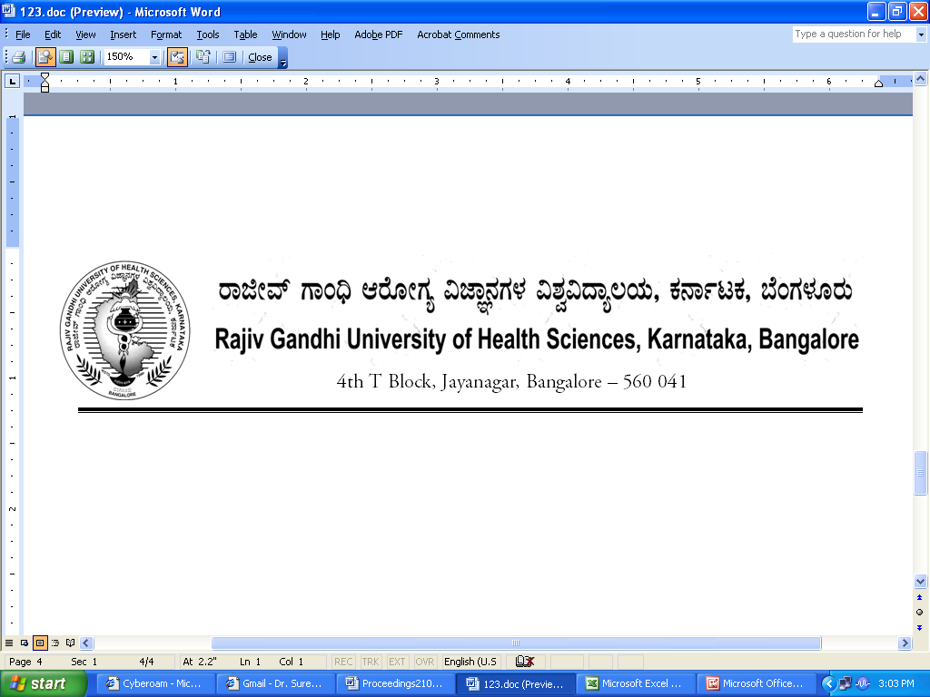
UA/FCL/NUR-3/2013-14 17/03/2014

NOTIFICATION

Sub : | Reconstitution of Faculty of Nursing.
Ref : | - University Notification No. RGH/STT-3/96-97 dated 23/12/1996 & ACA/STT-6/97-98 dated 03/11/1997 relating to Statutes Governing Faculties.  - University Notification No. UA/FCL/NUR-3/2010-11, dated: 02/02/2011.  - University Notification for constitution of Board of Studies in  Nursing (PG) No. UA/ BOS-12/2012-13,Dated: 03.10.2012.  4. University Notification for constitution of Board of Studies in  Nursing (UG) No. UA/ BOS-11 /2012-13,Dated: 03.10.2012.  5. University Notification for appointment of Dean of Faculty of  Nursing No. AUTH/DEANS/06/2013-14 dated 13.03.2014  6. Orders of Hon’ble Vice-Chancellor dated 15.03.2014

Constitution of the Faculty of Nursing of Rajiv Gandhi University of Health Sciences, Karnataka, Bangalore as contemplated under statutes relating to faculties referred to at (1) above is hereby notified as follows:

1. | Dean:  Mrs.Madhumathi,  Principal, Vydehi Nursing College, Whitefield, Bangalore
2. | Chairpersons of Boards of Studies :  1. Prof. K V Sridhar, Chairman, BOS in Nursing (PG) Principal, Fortis Institute of Nursing, No. 20/5, Yelchennahalli Village, Kanakapura Road, Bangalore – 560062  2. Smt. Lakshmidevi N, Chairman, BOS in Nursing (UG),Principal, Global College of Nursing, Global Academy of Technology Campus, Ideal Home Township, Rajarajeshwari Nagar, Bangalore – 560098
3 | Teachers nominated by the Vice-Chancellor  A) Professors
3 | 1. Dr.Suvarna Talwar, Govt. College of Nursing, Bangalore
3 | 2. Prof. Sunitha, Ramana Maharshi College of Nursing, Tumkur
3 | 3. Prof. Monica, Principal, HKE Society College of Nursing, Gulbarga
3 | B.)Associate Professors/Readers
3 | Mr. Satyanarayana, Asst. Professor, Kidwai Institute of Oncology, Bangalore
3 | Mrs. Resmi S, Asst. Professor, Gangothri College of Nursing, Bangalore
3 | - Mr.Nataraj, Asst. Professor, Sri. H.D.Devegowda College of Nursing,  Hassan
3 | C.)Lecturers/Assistant Professors
3 | Mr.Paramesh A E, Lecturer, Govt. College of Nursing, Mysore
3 | Mrs. Srilatha, Lecturer, Masood College of Nursing, Mangalore
3 | Mrs. Leena, Lecturer, SCS College of Nursing, Mangalore
4. | Experts nominated by the Vice-Chancellor in consultation with Syndicate
4. | - K N Suresh, Professor, N S Memorial College of Nursing, Palathara Thattamala, Kollam Dist., Kerala
4. | - Dr.M.Nagarathnam, Professor, SVIMS College of Nursing, Thirupathy, A P
4. | - Prof. Dr.Sr.Celsy Mary, Principal, St.Johns, College of Nursing, Bangalore
4. | - Dr.Madhavi, Principal, College of Nursing, Kovai Medical Centre, Coimbatore
4. | - Prof. Kathyayini, Principal, Dr.M.V.Shetty College of Nursing, Mangalore

The above Notification shall come into force with effect from 18.02.2014

By Order,
REGISTRAR
To
The Members of the Faculty of Nursing.
Copy to:
- The Secretary to Governor, Raj Bhavan, Bangalore – 560 001
- The Principal Secretary, Medical Education, Dept. of Health & Family Welfare, M.S. Building, Dr. B.R. Ambedkar Veedhi, Bangalore – 560 001
- The Secretary, Indian Nursing Council, Aiwan –E-Galib Marg, Kotla Road, Temple Lane, New Delhi – 110 002.
- The Principals of all colleges of Nursing affiliated to RGUHS.
- PA to Vice-Chancellor/Registrar /Registrar (Evaluation)/ Finance Officer, RGUHS.
- All Officers of the University
- The Members of the Syndicate, Senate & Academic Council of RGUHS.
- Office copy.

