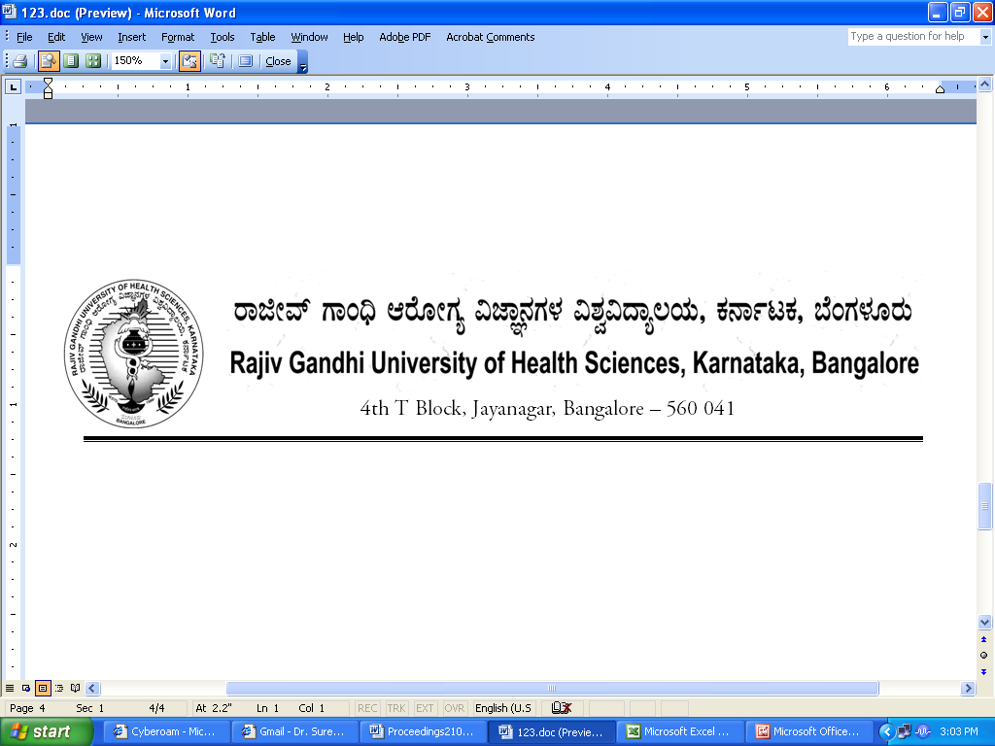
No. UA/FCL/PH-4/2013-14 Date: 17.03.2014

NOTIFICATION

Sub : | Reconstitution of Faculty of Pharmacy.
Ref : | - University Notification No. UA/FCL/PH-2/2001-02, dated 23/12/1996 & ACA/STT-6/97-98 dated 03/11/1997 relating to Statutes governing Faculties.  - No.UA/BOS-09/2003-04, dated 05/08/2003, Reconstitution of Board of Studies in Pharmacy [UG].  - University Notification No. UA/FCL/PH-3/2010-11, dated: 02/02/2011.  - University Notification for constitution of Board of Studies in  Pharmacy (PG) No. UA/ BOS-10/2012-13,Dated: 03.10.2012.  5. University Notification for constitution of Board of Studies in  Pharmacy (UG) No. UA/ BOS-09/2012-13,Dated: 03.10.2012.  6. University Notification for appointment of Dean of Faculty of  Pharmacy No. AUTH/DEANS/07/2013-14 dated 13.03.2014  7. Orders of Hon’ble Vice-Chancellor dated 15.03.2014
- - - -
The faculty of Pharmacy of Rajiv Gandhi University of Health Sciences, Karnataka, Bangalore is reconstituted as per statutes is hereby notified as indicated below.

1. | Dean:  Dr.Mohan, Principal, PES College of Pharmacy, Bangalore
2. | Chairpersons of Boards of Studies :  1. Dr. B.Ramesh, Chairman, BOS in Pharmacy (PG) &Principal, Sri Adichunchangiri College of Pharmacy, Nagamangala Taluk, Mandya Dist, BG Nagar - 571 448, Bellur  2. Dr. Doddaiah Hiremath, Chairman, BOS in Pharmacy (UG) &Principal,  N E T College of Pharmacy, P.B.No. 26, Navodaya Nagar, Mantralayam Road, Raichur 584 103

3 | Teachers nominated by the Vice-Chancellor  A) Professors
3 | 1. Dr. Raman Dang, Principal, Krupanidhi College of Pharmacy, Chikka Bellandur, Carmelaram Post, Varthur Hobli, Bangalore – 560 035
3 | 2. Dr. E.V.S. Subrahmanyam, Professor of Pharmaceutical Chemistry, Srinivasa College of Pharmacy, A Shama Rao Foundation, Hotel Srinivas, GHS Road, Mangalore 575 001
3 | 3. Prof. Hariprasanna R Chittapurkar, R.M.E.S.'s College of Pharmacy, Balaji Nagar, Old Jew Argi Road, Gulbarga – 585102,
 | B.)Associate Professors/Readers
1. Dr. Shivanand K Mutta, Associate Professor of Pharmaceutics, Acharya College of Pharmacy, Acharya Dr. Sarvepalli Radhakrishnan Road,
Acharya Post Office, Bangalore-560 107,

 | 2. Dr. R B Kotnal, Associate Professor of Pharmaceutical Chemistry, BLDEA’s College of Pharmacy, Post Box No. 40, Ashram Road, Engg College Campus, Bijapur – 586 103
 | 3. Dr. Narmada, Professor of Pharmaceutics, V V Puram College of Pharmacy, Bangalore
 | C.)Lecturers/Assistant Professors
 | 1. Mr. Basavaraj Bendegumble, Lecturer, HKES College of Pharmacy, Sedam Road, Gulbarga 585 105
 | 2. Dr. Basavaraj H, Assistant Professor of Pharmacology, Government College of Pharmacy, 2, P.Kalingarao Road, Subbaiah Circle, Bangalore 560 027
 | 3. Dr. Preethy, Assistant Professor of Pharmaceutics, Al Ameen College of Pharmacy, Hosur Road, Bangalore 560 027
4. | Experts nominated by the Vice-Chancellor in consultation with Syndicate
 | 1. Prof. Narasimha Reddy, Principal, Vivekananda College of Pharmacy, Bangalore
 | 2. Dr. B H M Jayakumara Swamy, Professor, SCS College of Pharmacy, Harapanahalli, Davanagere
 | 3. Dr. A P Basavarajappa, Principal, Bapuji College of Pharmacy, Davangere
4. Dr. Elango, Professor of Pharmacology, Jss College Of Pharmacy
"Rocklands” Post Box No.20, Udhagamandalam – 643 001
Tamil Nadu,
 | 5. Dr. Srinath, Professor of Pharmaceutics, Sonia Education Trust’s College of Pharmacy, Dharwad

The above Notification shall come into effect from 18/02/2011.

By Order,

REGISTRAR
To
The Members of the Faculty of Pharmacy.

Copy to:
- The Secretary to Governor, Raj Bhavan, Bangalore – 560 001.
- The Principal Secretary, Medical Education, Dept. of Health & Family Welfare, M.S. Building, Dr. B.R. Ambedkar Veedhi, Bangalore – 560 001
- The Secretary, All India Council for Technical Education, Indira Gandhi Sports Complex, I.P. Estate, New Delhi – 110 002.
- The Secretary, Pharmacy Council of India, Aiwan –E-Galib Marg, Kotla Road, Temple Lane, New Delhi – 110 002.
- The Principals of all colleges of Pharmacy affiliated to RGUHS.
- PA to Vice-Chancellor/Registrar /Registrar (Evaluation)/ Finance Officer, RGUHS.
- All Officers of the University
- The Members of the Syndicate, Senate & Academic Council of RGUHS.
- Office copy.

