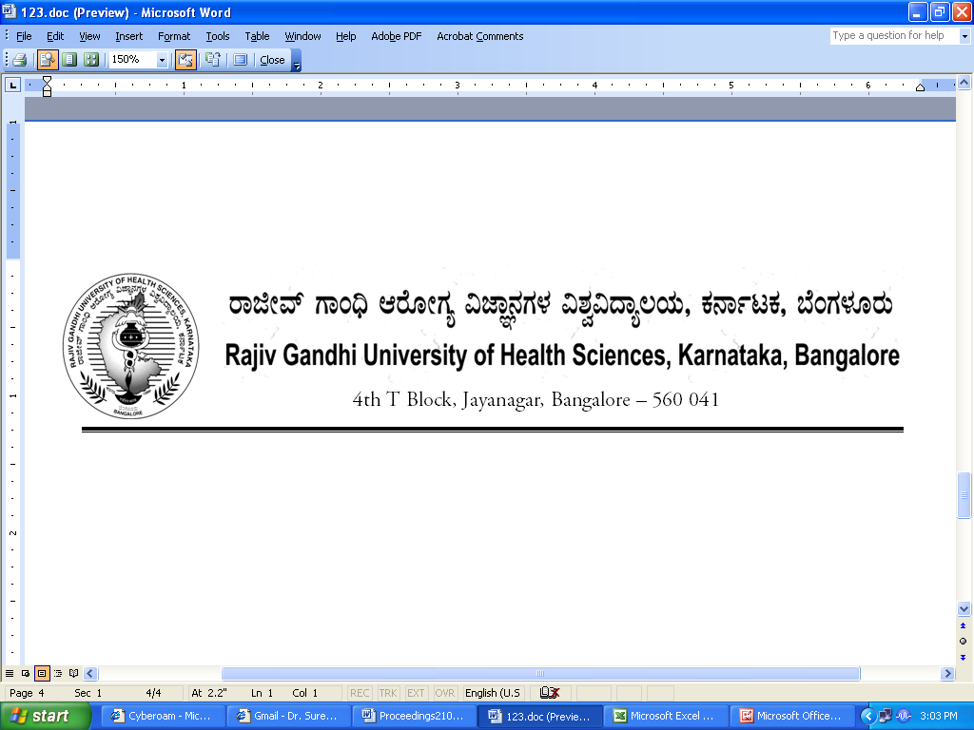
UA/Auth/FCL/AYUSH/5/2013-14 Date: 19.02.2014

NOTIFICATION

Sub: | Reconstitution of faculty of Indian System of Medicine including  Ayurveda, Unani & Naturopathy & Yoga-inclusion of member-Reg
Ref: 1) | University Notification No. RGH/STT-3/96-97 dated 23/12/1996 & ACA/STT-6/97-98 dated 03/11/1997 relating to Statutes Governing Faculties
2) | Notification No.UA/Auth/FCL/AYUSH/4/2010-11, dated: 02/02/2011
3) | University Notification for constitution of Board of Studies in Ayurveda (PG) No. UA/ BOS-16/2012-13 , dated: 03.10.2012
4) | University Notification for constitution of Board of Studies in Ayurveda (UG) No. UA/ BOS- 15/2012-13 , dated: 03.10.2012
5) | University Notification for constitution of Board of Studies in Unani No. UA/ BOS- 18/2012-13 , dated: 03.10.2012
6) | Orders of Hon’ble Vice-Chancellor dated 19.02.2014

* * *
Constitution of the Faculty of Indian System of Medicine including Ayurveda, Unani & Naturopathy & yoga of Rajiv Gandhi University of Health Sciences, Karnataka, Bangalore as contemplated under Statutes relating to faculties referred to at (1) above is hereby notified as follows:

FACULTY OF AYURVEDA, UNANI, NATUROPATHY AND YOGIC SCIENCES
1. | Dean:
2. | Chairpersons of Boards of Studies :  1. Dr. R. Vijayasarathy, Chairman, BOS in Ayurveda (PG) &  Prof. & Head. Of PG Shalyatantra, Government Ayurveda Medical College  Dhanvantri Road, Bangalore-560009  2. Dr. Gajanana Hegde, Chairman, BOS in Ayurveda (UG) &  Prof. & HOD of Kayachikitsa, Government Ayurvedic Medical College,  Sayyaji Rao Road, Vishweshwaraiah Circle , Mysore 570 021  3. Dr.Mohammed Anwar, Chairman, BOS in Unani Medicine &  Prof. & HOD, Ilaj-B-Tadbeer, National Institute of Unani Medicine  Magadi Road, Bangalore
3 | Teachers nominated by the Vice-Chancellor  A) Professors
3 | 1. Dr.B.R.Ramakrishna, Professor & HOD, Department of Dravya Guna, Sushrutha Ayurvedic Medical College & Hospital, Prashanthi Kuteeram, Jigani Hobli, Anekal Taluk, Bangalore 560 106
3 | 2. Dr. Gireesh N Danappa Goudar, Professor of Rasashastra & Bhaishajya Kalpana, Veerapulikeshi Rural Ayurvedic Medical College, Hospital & Research Center, Badami
3 | 3. Dr. Srinivas M, Professor, Department of Shalya Tantra, Athreya Ayurvedic Medical College, Doddaballapur 561 203
 | B.)Associate Professors/Readers
 | 1. Dr. Gururaj S Kulkarni, Asst. Professor, Department of Dravya Guna, BVVS Ayurveda Medical College & Hospital, Bagalkot 587 101
 | 2. Dr. Vijaya Mahantesh Chowdary, Assistant Professor, Department of Basic Principles, Alva’s Ayurvedic Medical College, Moodabidir 574 227
 | 3. Dr. Kuber Sankh, Asst. Professor, JSS Ayurvedic Medical College, Lalithadripura Road, Alanahalli, Mysore 570 028
 | C.)Lecturers/Assistant Professors
 | 1. Dr. Sujatha B Sir Nadagowda, Lecturer, Dept., of Prasoothi Tantra and Stree Roga, Sri Jagatguru Gavi Siddeshwara Ayurvedic Medical College, Koppal 583 231
 | 2. Dr. Umesh C, Lecturer, Department of Kaya Chikitsa, Sri Sri College of Ayurvedic Sciences and Research, 21st KM, PO Udayapura, Kanakapura Road, Bangalore 560 082
 | 3. Dr. Anitha S Mahajan, Lecturer, Shalya Tantra, Veerapulikeshi Rural Ayurvedic Medical College, Hospital & Research Center, Badami
4. | Experts nominated by the Vice-Chancellor in consultation with Syndicate
 | 1. Dr. Kishore Kumar R, Research Officer, National Ayurveda Dietetics’ Research Institute, Department of AYUSH, Ministry of Health and Family Welfare, GOI, NADRI, Government Central Pharmacy Annexe, Ashok Pillar, Jayanagar, Bangalore 560 011
 | 2. Dr. Manjunath N K, Director, School of Yoga and Naturopathy Medicine, Joint Director, Research and Development, SVYSA Prashanti Kuteeram, Jigani, Anekal Taluk, Jodi Bingipura, Jigani 560 106
 | 3. Dr. Rakshinda Subhani, Professor, HOD, Department of Pharmacology, Government Unani Medical College, Siddayya Puranik Road, Bangalore 560 079
 | 4. Dr. Vanitha S Shetty, Professor and Principal, Alva’s College of Naturopathy and Yogic Sciences, Moodbidire 574 227
 | 5. Dr. Suresh Negalaguli, Prof. & HOD, PNNM Ayurveda Medical College, PO Chiranthurthi, Dist Trissur, Kerala

The above Notification shall come into force with immediate effect.

By Order,

REGISTRAR

To

The Members of the Faculty of Indian System of Medicine including Ayurveda, Unani & Naturopathy & yoga.

Copy to:

- The Secretary to Governor, Raj Bhavan, Bangalore- 560 001.
- The Principal Secretary, Medical Education, Department of Health & Family Welfare, Vikasa Soudha, Bangalore.
- The Secretary, Central Council of Indian Medicine, Institutional Area, Janakpuri, New Delhi- 110 058.
- The Principals of all colleges of Indian System of Medicine i.e., Ayurveda, Unani, Naturopathy & Yoga affiliated to RGUHS.
- PA to Vice-Chancellor/Registrar/Registrar (Evaluation)/Finance Officer, RGUHS.
- Guard File/Office Copy.

