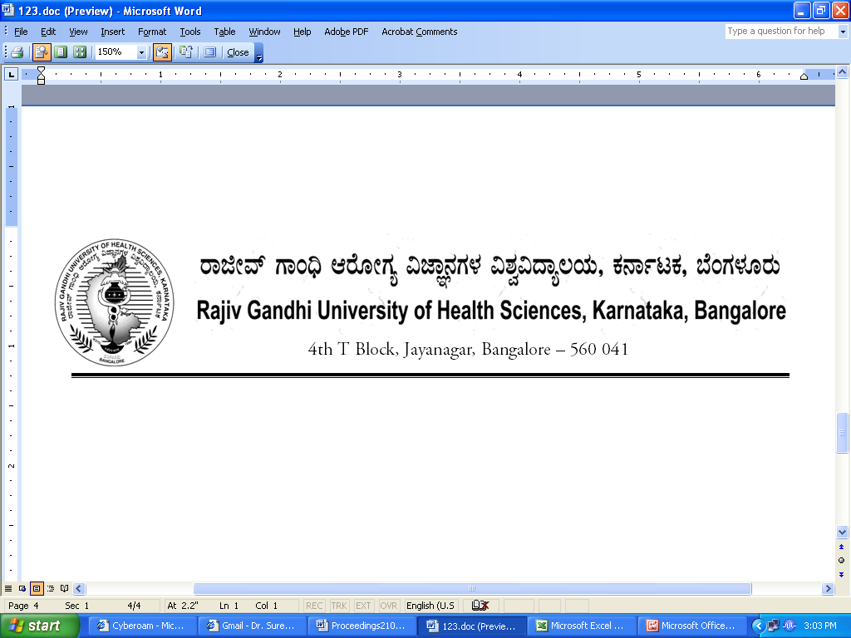
No. UA/Auth/FCL/Dental/5/2013-14 Date: 19.02.2014

NOTIFICATION

Sub: | Reconstitution of faculty of Dentistry –Reg.
Ref:1) | University Notification No. RGH/STT-3/96-97 dated 23/12/1996 & ACA/STT-6/97-98 dated 03/11/1997 relating to Statutes Governing Faculties.
2) | No. UA/Auth/FCL/Dental/4/2010-11, dated: 02/02/2011
3) | University Notification for constitution of Board of Studies in Dental (PG) No. UA/ BOS-8/2012-13, Dated: 03.10.2012
4) | University Notification for constitution of Board of Studies in Dental (UG) No. UA/ BOS-7/2012-13 Dated: 03.10.2012.
5) | Orders of Hon’ble Vice-Chancellor dated 19.02.2014

Constitution of the Faculty of Dentistry of Rajiv Gandhi University of Health Sciences, Karnataka, Bangalore as contemplated under Statutes relating to faculties referred to at (1) above is hereby notified as follows:

1. | Dean:
2. | Chairpersons of Boards of Studies :  1. Dr.C.S.Ramachandra, Chairman, BOS in Dentistry (PG),  Principal, AECS Maaruti College of Dental Sciences & Research Centre,  Hulimavu Tank Bund Road, BTM 6th Phase, 1st Stage, Kammanahalli, Off  Bannerghatta Road, B’lore – 76.  2. Dr.Girish B Giraddi, Chairman, BOS in Dentistry (UG) &  Professor and Head, Department of Oral and Maxillofacial Surgery  Government Dental CollegeBangalore
3 | Teachers nominated by the Vice-Chancellor  A) Professors
3 | - 1. Dr. Srinivas Vanaki, Professor, Dept., of Oral Pathology, P M Nadagowda Memorial Dental College, Raichur-Bagalkote Rd, Ward No 10, Bagalkot, 587101
3 | - Dr. Giridhar Kamath P, Professor of Prosthodontics, Sharavathi Dental College, Alkola, Shimoga 577204,
3 | 3. Dr. Pradeep P R, Professor of Endodontics, M R Ambedkar Ambedkar Dental College, 1/36, Cline Road, Cooke Town, Bangalore 560 005
 | B.)Associate Professors/Readers
 | - 1. Dr. Poornima R, Reader, Dept., of Oral Medicine, Bapuji Dental College, MCC B Block, University BDT College of Engineering, Davangere 577002
 | 2. Dr. Vivekananda M R, Reader, Dept., of Periodontics, Sri Hasanamba Dental College, P.B. No. 86, Vidyanagar, Hassan, Karnataka – 573 201
 | 3. Dr. Girish M S, Reader, Dept., of Pedodontics, M S Ramaiah Dental College And Hospital, M S Ramaiah Educational Campus, MSRIT Post, M S R Nagar, Bangalore – 560054
 | C.)Lecturers/Assistant Professors
 | 1. Dr. Revan Kumar Joshi, Lecturer, Dept of Oral Medicine and Radiology D A Pandu Memorial R V Dental College, 24th Main Rd, II Phase J P Nagar, Bangalore, 560078
 | 2. Dr. Arshed Hussain, Lecturer, Dept of Orthodontics, Al Badar Rural Dental College, Kotnoor, Gulbarga 585102
 | 3. Dr. Gautam Jayade, Lecturer, Dept of Oral and Maxillofacial Surgery, SDM Dental College. Dharwad Hubli Dharwad Hwy, Sattur, Hubli-Dharwad 580009
4. | Experts nominated by the Vice-Chancellor in consultation with Syndicate
 | 1. Dr. V Venkatesh, Professor, Dept., of Oral and Maxillofacial Surgery, Kamineni Institute of Dental Sciences, Sreepuram, Narketpalli – 508254, Nalgonda District, Andhra Pradesh
 | 2. Dr. V Anitha, Professor, Dept of Periodontics, Chettinad Dental College and Research Institute, IT Highway, Kelambakkam Chennai
 | 3. Dr. S M. Jayakar, Professor of Prosthodontics, AECS Maaruthi College of Dental Sciences & Research Centre, Hulimavu Tank Bund Road, BTM 6th Phase, I Stage, Kammanahalli, Off Bannerghatta Road, Bangalore 560 076
 | 4. Dr. Srivastava B.K, Professor and HOD, Dept., of Public Health Dentistry, KLE Institute of Dental Sciences, No.20, Yeshwanthpura Suburb, II Stage, Tumkur Road, Bangalore 560 022
 | 5. Dr. Raghavendra Kini, Professor. Dept of Oral Medicine and Radiology, AJ Institute of Dental Sciences, Kuntikana, NH-17, Mangalore - 575 004.

The above Notification shall come into force with immediate effect.

By Order,

REGISTRAR
To

The Members of the Faculty of Dentistry.

Copy to:
- The Secretary to Governor, Raj Bhavan, Bangalore- 560 001
- The Principal Secretary, Medical Education, Department of Health & Family Welfare, Vikasa Soudha, Bangalore
- The Secretary, Dental Council of India, Aiwan-E-Galib Marg, Kotla Road, Temple Lane, New Delhi- 110 002
- The Principals of all Dental colleges affiliated to RGUHS

