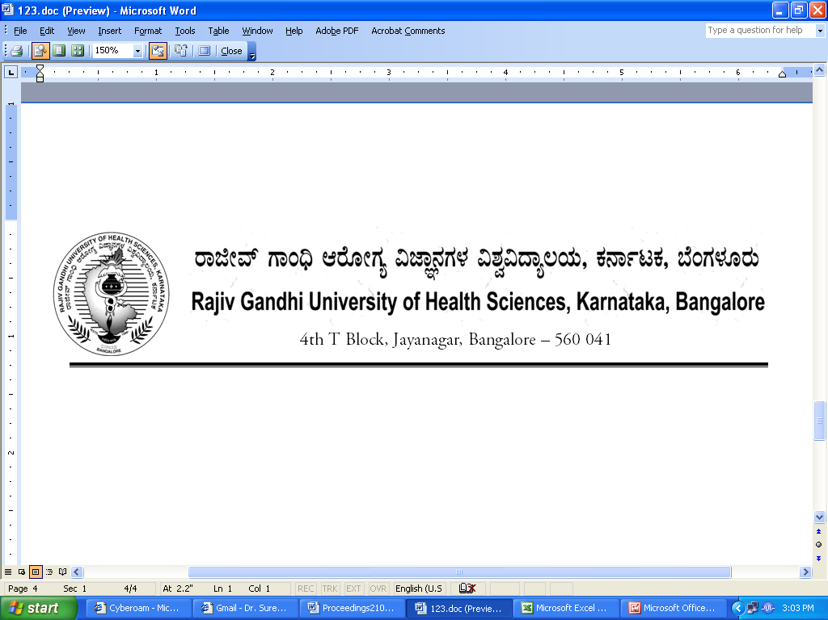
No. UA/FCL/M-4/2013-14 Date:20.02.2014

NOTIFICATION

Sub : | Reconstitution of Faculty of Medicine.
Ref : | - University Notification No. RGH/STT-3/96-97 dated 23/12/1996 & ACA/STT-6/97-98 dated 03/11/1997 relating to Statutes governing Faculties.  - University Notification No. UA/FCL/M-3/2010-11, Dated: 02/02/2011  - University Notification for constitution of Board of Studies in Pre-Clinical (UG) No. UA/ BOS-1/2012-13 Dated: 03.10.2012  - University Notification for constitution of Board of Studies in Pre-Clinical (PG) No. UA/ BOS-2/2012-13 Dated: 03.10.2012  - University Notification for constitution of Board of Studies in Para-Clinical (UG) No. UA/ BOS-3/20012-13 Dated: 03.10.2012  - University Notification for constitution of Board of Studies in Para-Clinical (PG) No. UA/ BOS-4/2012-13 Dated: 03.10.2012  - University Notification for constitution of Board of Studies in Clinical (UG) No. UA/ BOS- 5/2012-13 Date:31.7.2012  - University Notification for constitution of Board of Studies in Clinical (PG) No. UA/ BOS- 6/2012-13 Date:31.7.2012.  - Minutes of 105th Meeting of Syndicate held on 18.01.2014  - Orders of Hon’ble Vice-Chancellor dated 20.02.2014

Constitution of the Faculty of Medicine of Rajiv Gandhi University of Health Sciences, Karnataka, Bangalore as contemplated under statutes relating to faculties referred to at (1) above is hereby notified as follows:

 | Dr.K.S.Ravindranath, Prof. of Cardiology and Vice-Chancellor, Rajiv Gandhi University of Health Sciences, Karnataka, Bangalore. Ex-Officio Member.
1. | Dean:
2. | Chairpersons of Boards of Studies :  - Dr. Sandhya T Avadhany, Chairperson in Pre-Clinical (PG),Vice-Dean, Professor & Head, Department of Physiology,St. John’s Medical College, Sarjapur Road, Bangalore - 560 034  - Dr. H L Vishwanath, Chairman, BOS in Pre-Clinical (UG),Professor & HOD of Biochemistry, Bangalore Medical College & Research Institute,Fort, Bangalore 560 002  - Dr. Ranganath, Chairman, BOS in Para-Clinical (PG),Professor & HOD of Community Medicine, Bangalore Medical College & Research Institute Fort, Bangalore 560 002  - Dr. Jayanthi C R,Chairperson, BOS in Para-Clinical (UG),Prof. & HOD of Pharmacology,Bangalore Medical College & Research Institute, Fort, Bangalore 560 002  - Dr.Gopal, Chairman, BOS in Clinical (PG) & Professor of OBG, Adichunchangiri Institute of Medical Sciences, Balagangadharanatha Nagara, Nagamangala Taluk, Mandya District, B.G.Nagar – 571 448  - Dr.Nisarga,Chairman, BOS in Clinical (UG),Professor of Paediatrics,Adichunchanagiri Institute of Medical Sciences,Balagangadharanatha Nagara,Nagamangala Taluk, Mandya District BG Nagr-571 448  - Prof. Reshma Lobo, Principal & Chairman, BOS in Allied Health Sciences, Padmashree College of Hospital Administration, No. 23, Sri Gurukrupa Layout, 80 Ft. Road, Nagarbhavi, Bangalore – 560072  - Pradeep Shankar, Chairman, BOS in Physiotherapy, Vice-Principal, JSS College of Physiotherapy, J.S.S. Hospital Campus, Ramanuja Road, Mysore
3 | Teachers nominated by the Vice-Chancellor  A) Professors
3 | 1. Dr. Shreedhar Murthy, Professor of Medicine, Basaveshwara Medical College, BMCH Rd, Hanumantha Nagara, Chitradurga 577502
3 | 2. Dr. Rudresh H.K, Professor of Surgery, M S Ramaiah Medical College and Teaching Hospital, M S Ramaiah Nagar, MSRIT, Mathikere, Bangalore 560054
3 | 3. Dr. Mahendra B J, Professor and HOD of Community Medicine, Mandya Institute of Medical Sciences, Bangalore - Mysore road, Mandya 571 401
 | B.)Assistant Professors/Readers
 | 1. Dr. Ranganath H.D, Assistant Professor of Orthopedics, Kempegowda Institute of Medical Sciences, Banashankari 2nd stage Bangalore-560 070
 | 2. Dr. Ravibabu, Associate Professor in Hospital Administration, Vydehi Institute of Medical Sciences and Research Centre, #82, Nallurahalli, Near BMTC 18th Depot, Whitefield, Bangalore - 560 066
 | 3. Dr. Madan Ballal , Associate Professor of Orthopedics, Sanjay Gandhi Institute of Trauma and Orthopedics, Byrasandra Bangalore 11
 | C.)Lecturers/Assistant Professors
 | 1. Dr. Suresh Kanakannanavar, Assistant Professor of Obstetrics and Gynecology, Bangalore Medical College and Research Centre Institute, Fort, Bangalore 560 002
 | 2. Dr. S.M.Purushotham, Assistant Professor of Physiology, Mysore Medical College and Research Institute, Irwin Road, Mysore‐570021,
 | 3. Dr. D. Vishwanath, Assistant Professor of Forensic Medicine, Hassan Institute of Medical Sciences, Hassan
4. | Experts nominated by the Vice-Chancellor in consultation with Syndicate
 | 1. Dr. D V Chalapathy, Professor of Surgery, Vydehi Institute of Medical Sciences and Research Centre, #82, Nallurahalli, Near BMTC 18th Depot, Whitefield, Bangalore - 560 066
 | 2. Dr. Vishwanath Reddy, Professor of Ophthalmology, M R Medical College, Gulbarga
 | 3. Dr. G K Ramachandrappa, Professor of Anatomy, RajaRajeshwari Medical College and Hospital, No.202, Kambipura, Mysore Road, Bengaluru-560 074.
 | 4. Dr.S M Siddesh, Professor of Microbiology, ESI Medical College, Gulbarga
 | 5. Dr. Somashekar S.A, Associate Professor of Orthopedics, Bangalore Medical College and Research Institute, Fort, Bangalore 560 002

The above Notification shall come into force with immediate effect.

By Order,

REGISTRAR
To
The Members of the Faculty of Medicine.

Copy to:
- The Secretary to Governor, Raj Bhavan, Bangalore – 560 001
- The Principal Secretary, Medical Education, Dept. of Health & Family Welfare, M.S. Building, Dr. B.R. Ambedkar Veedhi, Bangalore – 560 001
- The Secretary, Indian Medical Council, India Aiwan-E-Galib Marg,Kotla Road,opposite Matha Sundari College for Women, New Delhi – 110 002.
- The Principals of all Medical colleges affiliated to RGUHS.
- PA to Vice-Chancellor/Registrar /Registrar (Evaluation)/ Finance Officer, RGUHS.
- All Officers of the University.
- The Members of the Syndicate, Senate & Academic Council of RGUHS.
- Guard file, Office copy.

