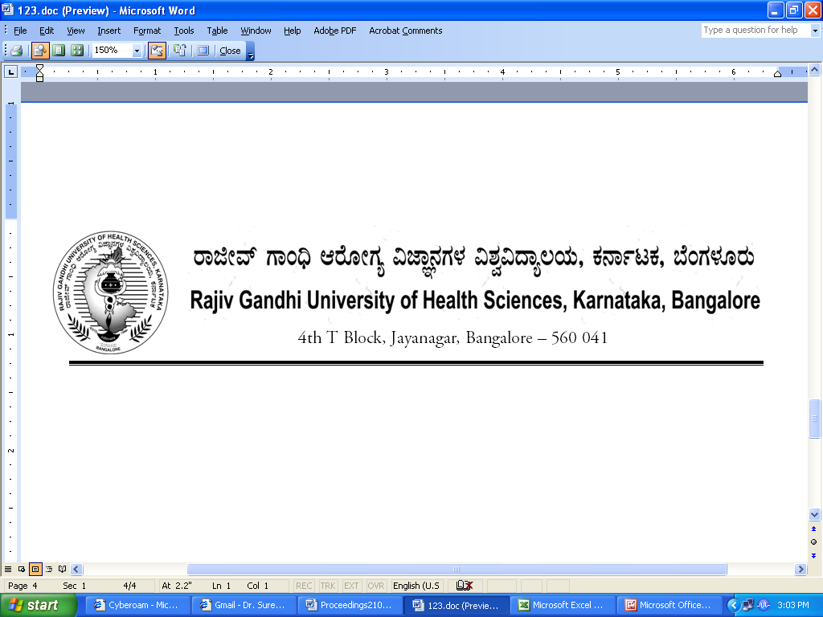

No. UA/ BOS-19/2012-13 Date:03.10.2012

NOTIFICATION

Sub: Reconstitution of Board of Studies in Physiotherapy
Ref: 1. This office Notification No. UA/BOS-19/2009-10 dated 31.7.2009
2. Minutes of the meeting of the 100th syndicate held on 28.8.2012

Pursuant to the decision of the syndicate in its meeting held on 28th August 2012, the Vice-Chancellor has been pleased to reconstitute the Board of Studies in Physiotherapy with the following members with effect from 31.07.2012 for a period of three years.

Chairman

Pradeep Shankar
Vice-Principal
JSS College of Physiotherapy
J.S.S. Hospital Campus, Ramanuja Road,
Mysore

Members

02 | Prof. Prabhu C.  Professor  Padmashree Institute of Physiotherapy,  23, Gurukrupa Layout,  80 feet Road, Nagarabhavi Circle, Bangalore – 560 072 | 03 | Mohammad Suhail  Dr. M V Shetty College of Physiotherapy  Institute of Health Sciences, Vidyanagar, Panjimoguru, Mangalore
04 | S.Arul Dhanaraj  Principal  Laxmi Memorial College of Physiotherapy, A J Towers, Balmatta, Mangalore | 05 | A. Joseph Oliver Raj  Principal  Alva's College of Physiotherapy  Alvas Health Centre Complex,  Near New Bus Stand, Moodbidri, D.K.
06 | Masih Muhammad Khan  Principal  Krupanidhi College of Physiotherapy  72/1, Outer Ring Road, Bellandur, Bangalore | 07 | Mathew Anand  Asso. Professor  Dayananda Sagar College of Physiotherapy  Shavige Malleshwara Hills, Kumaraswamy Layout, Bangalore
08 | Vijay P  Principal  Shreedevi College of Physiotherapy  Maina Tower, Ballalbagh, Mangalore | 09 | Prof. Sai Kumar N  Principal  KTG College of Physiotherapy  Hegganahalli Cross, Sunkada Katte, Vishwaneedan Post, Via Magadi Road,  Bangalore
10 | Pitchaiah  Asso. Professor  Srinivas College of Physiotherapy  Hotel Srinivas Building,  GHS Road, Mangalore | 11 | Mrs. Anjali Suresh  Principal  Garden City College of Physiotherapy  Garden City College Campus  16th KM, Old Madras Road, Bangalore - 560 049
12 | Prem kumar B.N.  Asst. Prof.  Kempegowda Institute of Physiotherapy  K R Road, V V Puram, Bangalore | 13 | Sanjay Parmar  Asso. Professor  SDM College of Physiotherapy  Dhavalnagar, Dharwad
14 | Manjunath H  Principal  Florence College of Physiotherapy  No. 509, 1 'D' Main, 3rd Block, Kalyan nagar, H R B R Layout, St. Thomas Town Post, Bangalore | 15 | Narasimman S  Professor  Fr. Muller's Medical College,(Physiotherapy Course)  P. O Box 501, Fr.Muller's Road, Kankanady, Mangalore

External Members

1 | Mr.Anand V  Principal  Saveetha College of Physiotherapy  No.162, Poonamalle High Road  Velpappan Chavadi,  Chennai – 602 105 | 2 | Dr. Ali Irani  HoD, Nanavathi College of Physiotherapy, Nanavathi Hospital  Ville Parle Road (West)  Mumbai - 56

By Order,

REGISTRAR

To
The Members Concerned

Copy to

- The Members of the Syndicate of RGUHS
- PA to Vice-Chancellor / Registrar / Registrar (Evaluation) / Finance Officer, RGUHS
- Director, Curriculum Development Cell / Public Information Officer / All officers of the University / RGUHS Website / Guard File / Office copy

