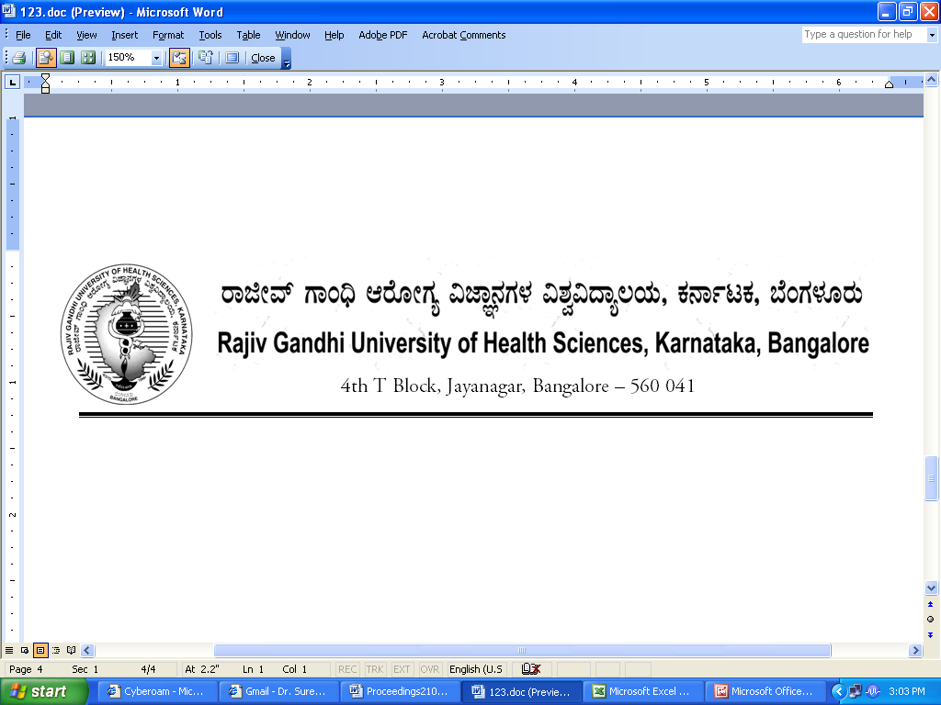

No. UA/ BOS-9/2012-13 Date:03.10.2012

NOTIFICATION

Sub: Reconstitution of Board of Studies in Pharmacy (UG)
Ref: 1. This office Notification No. UA/BOS-09/2009-10 dated 31.7.2009
2. Minutes of the meeting of the 100th syndicate held on 28.8.2012

Pursuant to the decision of the syndicate in its meeting held on 28th August 2012, the Vice-Chancellor has been pleased to reconstitute the Board of Studies in Pharmacy (UG) with the following members with effect from 31.07.2012 for a period of three years.

Chairman

Dr. Doddaiah Hiremath,
Principal,
N E T College of Pharmacy
P.B.No. 26, Navodaya Nagar,
Mantralayam Road,
Raichur 584 103

Members

02 | Prof. Khamboja,  Prof. of Pharmacognosy,  Oxford College of Pharmacy,  6/9, 1st Cross, Begur Road, Hongasandra,  Bangalore – 560 068 | 03 | Prof. Thimma Shetty  Prof. of Pharmaceutics  Bapuji College of Pharmacy  Davanagere.
04 | Prof. M S Shandyavali,  Prof. of Pharmachemistry,  Dayananda Sagar College of Pharmacy,  Shivage Malleshwara Hills Kumaraswamy Layout, Bangalore 560078 | 05 | Dr. Chandrashekar Sultanpure,  Asso. Prof. of Pharmacology,  Government College of Pharmacy,  No.2, P.Kalinga Rao Road, Subbaiah Circle,  Bangalore - 560 027
06 | Prof. Asha,  Prof. of Pharmaceutics,  Al-Ameen College of Pharmacy, Hosur Road, Opp. Lalbagh Main Gate, Bangalore - 560 027 | 07 | Dr. Hanumantha Rao Joshi, Principal,  Sharada Vilas College of Pharmacy, Sarada Vilas Road, Krishnamurthypuram,  Mysore- 570 004
08 | Dr. Katta Sridhar,  Principal,  East West College of Pharmacy,  No. 63, I Phase, B.E.L.  Layout, Bharathnagar,  Vishwaneedam Post,  off Magadi Road, Bangalore 91 | 09 | Dr. C Narendra,  Asst. Professor of Pharmaceutics, Visveswarapura Institution of Pharmaceutical Sciences  24th Main Road, 25th cross, BSK II Stage, Opp. BDA Complex, Bangalore 560 070
10 | Prof. Shreenivas R Deshpande,  Prof. of Pharma chemistry,  Hanagal Shri Kumareshwar  College of Pharmacy  BVVS Campus, Bagalkot-587101 | 11 | Prof. Kishore Singh,  Prof. of Pharma chemistry,  Rajeev Memorial College of Pharmacy,  Balaji Nagar Old Jewargi Road, Gulbarga 585102
12 | Dr. Kashinath Nawbade,  Prof. of Pharmachemistry,  Karnataka College of Pharmacy,  PB No.53, Manahalli Road,  Bidar - 585 403 | 13 | Dr. K C Prashanth Kumar, Lecturer in Pharmacognosy,  National College of Pharmacy,  Balraj Urs Road,  Shimoga – 577201
14 | Prof. Shalin Thakkar,  Professor of Pharamaceutics,  S.E.T’s College of Pharmacy,  S R Nagar, Near Microwave Tower, Dharwad, Hubli 580002 | 15 | Dr. (Mrs) Kirana,  Asst. Professor of Pharmacognosy,  T V M College of Pharmacy, Bellary 583 103

External Members
1 | Dr. Anna Balaji  Prof. of Pharmaceutics & Principal  Trinity College of Pharmaceutical Sciences  Peddapally, Karimanagar 505 172  Andhra Pradesh | 2 | Dr. Unni Krishnan  Professor  College of Pharmaceutical Sciences  Manipal 576104
By Order,

REGISTRAR

To
The Members Concerned

Copy to

- The Members of the Syndicate of RGUHS
- PA to Vice-Chancellor / Registrar / Registrar (Evaluation) / Finance Officer, RGUHS
- Director, Curriculum Development Cell / Public Information Officer / All officers of the University / RGUHS Website / Guard File / Office copy

No. UA/ BOS-10/2012-13 Date:03.10.2012

NOTIFICATION

Sub: Reconstitution of Board of Studies in Pharmacy (PG)
Ref: 1. This office Notification No. UA/BOS-10/2009-10 dated 31.7.2009
2. Minutes of the meeting of the 100th syndicate held on 28.8.2012

Pursuant to the decision of the syndicate in its meeting held on 28th August 2012, the Vice-Chancellor has been pleased to reconstitute the Board of Studies in Pharmacy (PG) with the following members with effect from 31.07.2012 for a period of three years.

Chairman

Dr. B.Ramesh,
Principal
Sri Adichunchangiri College of Pharmacy,
Nagamangala Taluk, Mandya Dist,
BG Nagar - 571 448, Bellur

Members

02 | Dr. K.P.Chennabasavaraj,  Prof. of Pharma chemistry, Government College of Pharmacy,  No.2, P.Kalinga Rao Road, Subbaiah Circle,  Bangalore - 560 027 | 03 | Dr. Nagaraj,  Prof. of Quality Assurance,  P E S College of Pharmacy,  Hanumanthanagar, 50 Feet Road, BSK I Stage, Bangalore 560 050
04 | Dr. Jagadeesh Kamath,  Prof. of Pharmacology & Principal  Shreedevi College of Pharmacy, Airport Road, Kenjar Village, Malavoor Panchayat,  Mangalore 574142 | 05 | Dr. A.K. Beknal,  Prof. of Pharmacognosy,  HKE College of Pharmacy,  Sedam Road, Gulbarga 585 105
06 | Dr. V H Kulkarni,  Principal & Prof. of Pharmacology, SET’s College of Pharmacy,  Vidyagiri, Dharwad - 580 004 | 07 | Prof. Raghavendra Patil,  Prof of Pharmacology,  Karnataka College of Pharmacy,  PB No.53, Manahalli Road,  Bidar - 585 403
08 | Dr. Bheemachary,  Prof. of Pharmacology,  N E T College of Pharmacy  P.B.No. 26, Navodaya Nagar,  Mantralayam Road,  Raichur 584 103 | 09 | Mr. R.B.Kotnal,  Asst. Prof. of Pharma Chemistry,  BLDE College of Pharmacy,  Post Box no 40, Ashram Road, Engg College Campus,  Bijapur 586 103
10 | Dr. Suresh Kulkarni,  Prof. of Pharmachemistry, Siddaganga College of Pharmacy, B.H.Road, Tumkur 572 102 | 11 | Dr. Shivakumaraswamy,  Principal and Prof. of Pharmacology,  Mallige College of Pharmacy,  # 71, Silvepura, Chikkabanavara Post, Bangalore, - 560 090
12 | Dr. Rema Razdan,  Professor of Pharmacology,  Al-Ameen College of Pharmacy,  Hosur Road, Opp. Lalbagh Main Gate, Bangalore - 560 027 | 13 | Dr. S Bharath,  Professor of Pharmaceutics,  M S Ramaiah College of Pharmacy,  M S Ramaiah Nagar, MSRIT Post,  Bangalore 560 054
14 | Prof. Kumara Holla,  Prof of Pharmacognosy,  Visveswarapura Institution of Pharmaceutical Sciences  24th Main Road, 25th cross, BSK II Stage, Opp. BDA Complex, Bangalore 560 070 | 15 | Dr. Goli Diwakar,  Principal,  Acharya B M Reddy College of Pharmacy, No. 89/90, Soladevanahalli, Chikkabanavara Post, Hesaraghatta Road,  Bangalore - 560 090

External Members

01 | Dr. H G Shivakumar,  Principal,  J S S College of Pharmacy,  Sri Shivarathreeshwara Nagar  Mysore 570 015 | 02 | Dr. C S Shastry,  Principal,  N G S M College of Pharmacy, Nitte University,  Nitte, South Kanara

By Order,

REGISTRAR

To
The Members Concerned
Copy to

- The Members of the Syndicate of RGUHS
- PA to Vice-Chancellor / Registrar / Registrar (Evaluation) / Finance Officer, RGUHS
- Director, Curriculum Development Cell / Public Information Officer / All officers of the University / RGUHS Website / Guard File / Office copy

