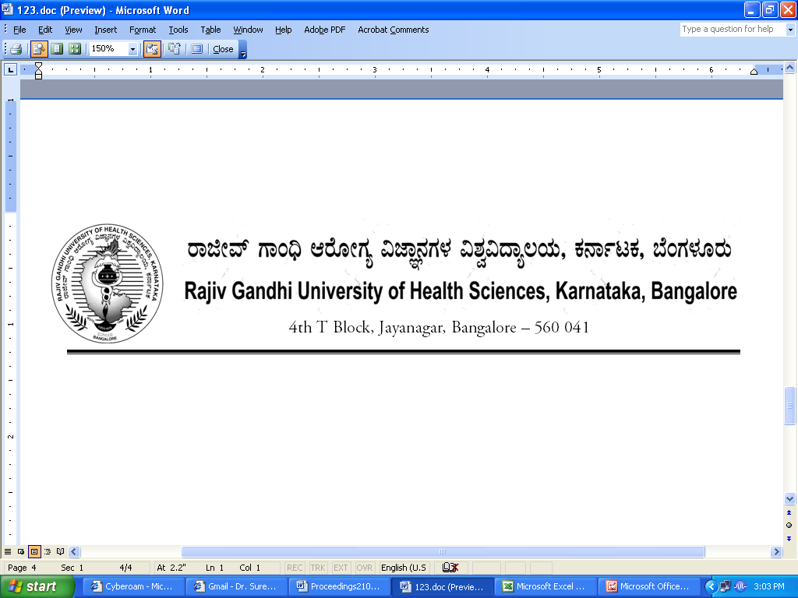

No. UA/ BOS- 11/2012-13 Dated 03.10.2012

NOTIFICATION

Sub: Reconstitution of Board of Studies in Nursing (UG)
Ref: 1. This office Notification No. UA/BOS- 11/2009-10 dated 31.7.2009
2. Minutes of the meeting of the 100th syndicate held on 28.8.2012

Pursuant to the decision of the syndicate in its meeting held on 28th August 2012, the Vice-Chancellor has been pleased to reconstitute the Board of Studies in Nursing (UG) with the following members with effect from 31.07.2012 for a period of three years.

Chairman

Smt. Lakshmidevi N,
Principal
Global College of Nursing
Global Academy of Technology Campus
Ideal Home Township, Rajarajeshwari Nagar
Bangalore - 560098

Members
02 | Mrs. Theresa Leonilda Mendonca  Professor of Pediatric Nursing  Laxmi Memorial College of Nursing A.J. Towers, Balmatta,  Mangalore 575 002 | 03 | Mrs. Leena K C  Prof., of Community Health  Nursing  Father Muller College of  Nursing, Father Muller Road,  Kankanady, Mangalore-575002
04 | Mr. Prakash H B  Lecturer  Government College of Nursing  Fort  Bangalore 560 002 | 05 | Mr. Paul Raj  Principal  # 26/3, Harina Complex, Sahakarinagar Layout, Yelahanka  Bengaluru 560092
06 | Mr. David Kolla  Professor  SDM Institute of Nursing Sciences  Manjushree Nagar, Sattur, Dharwad - 580 009 | 07 | Sr. Martha  Principal  St. Philomena College of Nursing  ST. PHILOMENA’S HOSPITAL  No.1, Mother Theresa Road, Viveknagar P.O Bangalore-47
08 | Mrs. Dorothy Deena Theodore Principal, Narayana Hrudayalaya  College of Nursing,  No # 258/A, Bommasandra Industrial Area, Anekal Taluk, Bangalore 560099 | 09 | Prof. Thippeswamy  Sri Nirvanaswamy College of Nursing  Sri Degula Math Campus  Kanakapura
10 | Mrs. Prathiba Braggs  Principal  Udupi Dhanwantari College of Nursing, Vasundara Nagar, Malpe Ashirvad Road, Santhekatte,  Udupi 576105 | 11 | Sri K Ramu  Principal  Shridevi College of Nursing,  Lingapura, Sira Road  Tumkur 572 106
12 | Mrs. Fathima  Principal  Padmashree College of Nursing,  No 23, 80 Ft Road,  Gurukrupa Layout, Nagarbhavi  Bangalore 560072 | 13 | Mr. T H Krishnamurthy  Karnataka Institute of Medical Sciences - College of Nursing  Vidyanagar, Hubli 580 022
14 | Mrs. Renilda Shanthi Lobo  Principal  City College of Nursing,  City Enclave, Shakthinagar, Mangalore-575016 | 15 | Dr. Sr. Alphonsa  Vice Principal  Athena College of Nursing  Athena Hospital Complex,  Falnir Road, Mangalore - 575 001

External Members

- Dr. Reena Evancy, Principal, St. Xavier Catholic College of Nursing, Chunkankankadai, Nagarcoil, Kanyakumari District, Tamilnadu
- Dr. Roy K George, Principal, Baby Memorial College of Nursing, Calicut 673016, Kerala

By Order,

REGISTRAR

To
The Members Concerned

Copy to

- The Members of the Syndicate of RGUHS
- PA to Vice-Chancellor / Registrar / Registrar (Evaluation) / Finance Officer, RGUHS
- Director, Curriculum Development Cell / Public Information Officer / All officers of the University / RGUHS Website / Guard File / Office copy

No. UA/ BOS-12/2012-13 Dated 03.10.2012

NOTIFICATION

Sub: Reconstitution of Board of Studies in Nursing (PG)
Ref: 1. This office Notification No. UA/BOS-12/2009-10 dated 31.7.2009
2. Minutes of the meeting of the 100th syndicate held on 28.8.2012

Pursuant to the decision of the syndicate in its meeting held on 28th August 2012, the Vice-Chancellor has been pleased to reconstitute the Board of Studies in Nursing (PG) with the following members with effect from 31.07.2012 for a period of three years.

Chairman

Prof. K V Sridhar
Principal
Fortis Institute of Nursing
No. 20/5, Yelchennahalli Village,
Kanakapura Road,
Bangalore - 560062

Members
02 | Mr. Dinesh Selvam S  Principal  Padmashri Institute of Nursing  Nagarbhavi Circle,  Bangalore-560072 | 03 | Mrs.V.T. Lakshmamma  Principal  Kempegowda College of Nursing  K R Road, V V Puram  Bangalore 560 004
04 | Mrs. Sheela William  Principal  JSS College of Nursing,  JSS College of Nursing,1st main  Saraswathipuram,  Mysore-09 | 05 | Miss. Jadhav Sonali Tarachand  Principal  Bhagwan Mahaveer Jain College of Nursing,  Millers Road, Vasanth Nagar  Bangalore 560052
06 | Mrs. R Sarojini Devi  Principal  Government College of Nursing  Holenarasipura, Hassan 573 211 | 07 | Mrs. Mercy P J  Prof. of Community Health Nursing  St. John’s College of Nursing  Hosur Road, Bangalore 560 047
08 | Mrs. Madhumathi,  Principal  Vydehi Institute of Nursing Sciences and Research Centre,  No 82, EPIP Area, Nallurahalli,  Near Whitefield) Bangalore 560066 | 09 | Dr.Nagarajappa  Principal  BVVS Nursing College  Bagalkot
10 | Mrs. Uma G  Principal  Nanjappa Institute of Nursing Sciences, Shimoga, Karnataka  K NO 5603 and 5619, Gadikoppa (Alkola), Sagar Road, Shimoga | 11 | Mrs. Asha P Shetty  Principal  K Pandyarajah Ballal Nursing Institute  Someshwar Road, Ullal  Mangalore 575020
12 | Mrs. M V Yashodamma,  Deam  Acharya College of Nursing,  51, cholanayakanahalli,  R T Nagar(po), Bangalore-32 | 13 | Mrs. Santham Lillypet A.  Prof., of Community Health Nursing  M S Ramaiah Institute of Nursing Education and Research  M S R Nagar, Mathikere  Bangalore 560 054
14 | Lt. Col. Prof. Suma  Principal  Unity College of Nursing  Unity Academy of Education,  Post Box, No. 535 Highlands, Kanakanady, Mangalore 575 002 | 15 | Mrs. Prabha Liss Thomas  Principal  Krupanidhi College of Nursing  Sarajapur Road,, Chickkanahalli  Bangalore 560 037

External Members

1 | Mrs. Ciby Jose  Prof of Psychiatry Nursing  Omayal Achi College of Nursing  No.45, Ambathur Road,  Puzhal, Chennai – 66  Tamilnadu | 2 | Prof. Anoopa Suresh  Vice Principal  Theophilus College of Nursing  Kangazha, Kottayam  Kerala

By Order,

REGISTRAR

To
The Members Concerned

Copy to

- The Members of the Syndicate of RGUHS
- PA to Vice-Chancellor / Registrar / Registrar (Evaluation) / Finance Officer, RGUHS
- Director, Curriculum Development Cell / Public Information Officer / All officers of the University / RGUHS Website / Guard File / Office copy

