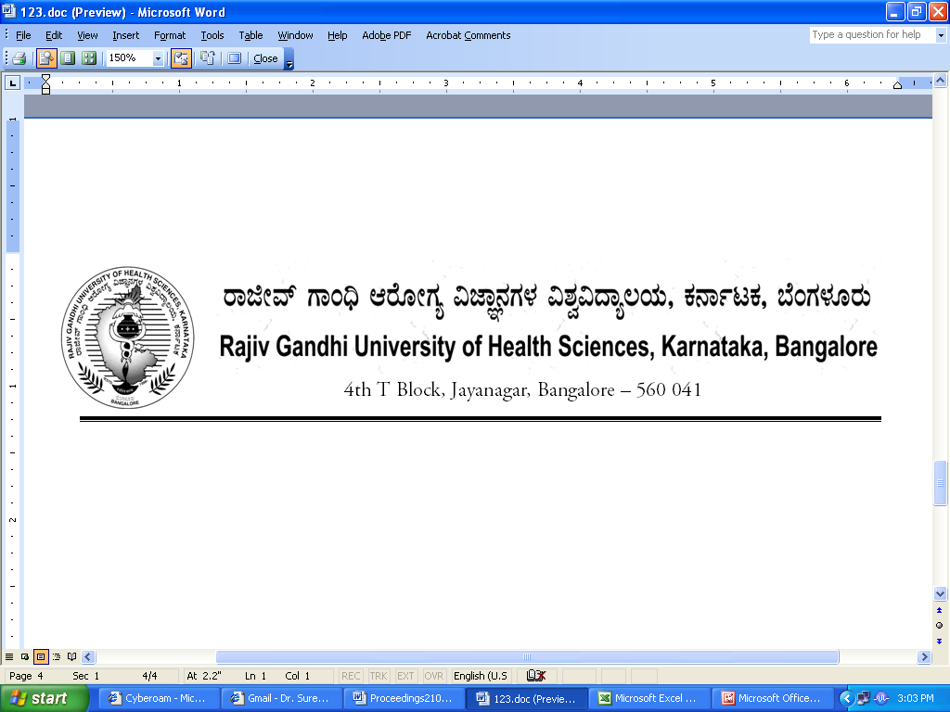
No. UA/ BOS-1/2012-13 Date: 03.10.2012

NOTIFICATION

Sub: Reconstitution of Board of Studies in Pre-Clinical (UG)
Ref: 1. This office Notification No. UA/BOS-01/2009-10 dated 31.7.2009
2. Minutes of the 100th meeting of the syndicate held on 28.8.2012

Pursuant to the decision of the syndicate in its meeting held on 28th August 2012, the Vice-Chancellor has been pleased to reconstitute the Board of Studies in Pre-Clinical (UG) with the following members with effect from 31.07.2012 for a period of three years.

Chairman

Dr. H L Vishwanath,
Professor & HOD of Biochemistry,
Bangalore Medical College & Research Institute,
Fort, Bangalore 560 002

Members

02 | Dr. S M Awanthi  Assoc. Professor of Biochemistry  M. R. Medical College,  Mahadevappa Marg,  Sedam Road, Gulbarga - 585 105 | 03 | Dr. Ashok Kumar,  Professor of Biochemistry,  A J Institute of Medical Sciences,  A J Institute Of Medical Sciences,  N.H-17, Kuntikana,  Mangalore - 575 004
04 | Dr. Sangita R Phatale  Assoc. Prof. of Physiology  M. R. Medical College,  Mahadevappa Marg,  Sedam Road, Gulbarga - 585 105 | 05 | Dr. Bhoosa Reddy,  Assoc. Professor of Anatomy,  Karnataka Institute of Medical Sciences  P.B.Road, Vidyanagar  Hubli 580 022
06 | Dr. Kshira Sagar,  Prof. & HOD of Anatomy  Bidar Institute of Medical Sciences  Udgir Road  Bidar | 07 | Dr. Neelima Bhandarkar  Assoc. Professor of Physiology  S Nijalingappa Medical College  Navanagar, Bagalkot 587 102
08 | Dr. Sucharita,  Professor of Physiology,  St. John’s Medical College,  Sarjapur Road,  Bangalore - 560 034 | 09 | Dr. Muralidhar Krishna  Professor of Biochemistry  Bangalore Medical College & Research Institute, Fort,  Bangalore 560 002
10 | Dr. Sreenivasalu Naidu  Professor of Physiology  Bangalore Medical College & Research Institute, Fort,  Bangalore 560 002 | 11 | Dr. Prakash B S  Assoc. Prof. of Anatomy  Dr. B R Ambedkar Medical College  Kadugondanahalli  Bangalore 560 045
12 | Dr. Pushpa,  Professor of Physiology,  Bangalore Medical College & Research Institute, Fort,  Bangalore 560 002 | 13 | Dr. S Riyaz Bhasha,  Professor of Anatomy,  Bangalore Medical College & Research Institute, Fort,  Bangalore 560 002
14 | Dr. Anitha D  Prof. of Biochemistry  St. John’s Medical College,  Sarjapur Road,  Bangalore - 560 034 | 15 | Dr. Priya Ranganath,  Professor of Anatomy,  Bangalore Medical College & Research Institute, Fort,  Bangalore 560 002

External Members

1 | Dr. Vinutha Shankar M.S  Professor of Physiology  Sri Devaraj Urs Medical College  Tamaka, Kolar | 2 | Dr. Lakshmi prabha Subash  Prof. & HOD of Anatomy  Sri Siddartha Medical College  Agalakote, B.H.Road,  Tumkur 572107

By Order,

REGISTRAR

To
The Members Concerned

Copy to
- The Members of the Syndicate of RGUHS
- PA to Vice-Chancellor / Registrar / Registrar (Evaluation) / Finance Officer, RGUHS
- Director, Curriculum Development Cell / Public Information Officer / All officers of the University / RGUHS Website / Guard File / Office copy

No. UA/ BOS-2/2012-13 Date: 03.10.2012

NOTIFICATION

Sub: Reconstitution of Board of Studies in Pre-Clinical (PG)
Ref: 1. This office Notification No. UA/BOS-02/2009-10 dated 31.7.2009
2. Minutes of the 100th meeting of the syndicate held on 28.8.2012

Pursuant to the decision of the syndicate in its meeting held on 28th August 2012, the Vice-Chancellor has been pleased to reconstitute the Board of Studies in Pre-Clinical (PG) with the following members with effect from 31.07.2012 for a period of three years.

Chairperson

Dr. Sandhya T Avadhany,
Vice-Dean, Professor & Head
Department of Physiology
St. John’s Medical College,
Sarjapur Road, Bangalore - 560 034

Members

02 | Dr. Roopa Kulkarni  Prof. of Anatomy  M S Ramaiah Medical College & Research Institute, M S R Nagar  Mathikere, Bangalore 560 054 | 03 | Dr. Varsha Mokshi  Prof. & HOD of Anatomy  Vydehi Institute of Medical Sciences & Research Centre, 82, EPIP Area, Whitefield, Bangalore 560066
04 | Dr. R Shubha  Prof. of Anatomy  Kempegowda Institute of Medical Sciences,  Banashankari 2nd Stage,  Bangalore-560070 | 05 | Dr. Malathi  Prof. & HOD of Biochemistry  Father Muller Medical College  Father Muller Road,  Kankanady, Mangalore - 575 002,
06 | Dr. Vidya S Patil  Assoc. Prof. of Biochemistry  S D M Medical College  Manjushri Nagar, Sattur,  Dharwad - 580 009 | 07 | Dr. Vijaya Krishna K  Prof. of Physiology  S Nijalingappa Medical College  Navanagar, Bagalkot 587 102

08 | Dr. S Meera  Prof. & HOD of Biochemistry  Mysore Medical College  Irwin Road, Mysore 570 001 | 09 | Dr. K R Dakshayani  Prof. & HOD of Anatomy  Mysore Medical College  Irwin Road, Mysore 570 001
10 | Dr. M L Revathi Devi  Prof. of Physiology  Mysore Medical College  Irwin Road, Mysore 570 001 | 11 | Dr. Roopa Ravindranath  Prof. & HOD of Anatomy  St. John’s Medical College,  Sarjapur Road,  Bangalore - 560 034
12 | Dr. Manjunath M Tembad  Prof. of Biochemistry  J J M Medical College  MCC B Block, Davanagere | 13 | Dr. Suresh Bondade  Prof. of Physiology  J J M Medical College  MCC B Block, Davanagere
14 | Dr. Shankarappa  Prof. & HOD of Physiology  Vydehi Institute of Medical Sciences & Research Centre, 82, EPIP Area, Whitefield, Bangalore 560066 | 15 | Dr. B V Ravi  Prof. & HOD of Biochemistry  Kempegowda Institute of Medical Sciences  Banashankari 2nd Stage,  Bangalore-560070

External Members

1 | Dr. P B Desai  Prof. & HOD of Biochemistry  J N Medical College  Nehru Nagar, Belgaum 590 010 | 2 | Dr. B G Patil  Prof. of Anatomy  B L D E A’s Shri B M Patil Medical College, Hospital and Research Centre  Bijapur

By Order,

REGISTRAR

To
The Members Concerned

Copy to
- The Members of the Syndicate of RGUHS
- PA to Vice-Chancellor / Registrar / Registrar (Evaluation) / Finance Officer, RGUHS
- Director, Curriculum Development Cell / Public Information Officer / All officers of the University / RGUHS Website / Guard File / Office copy

MEETING OF THE BOS IN PRE CLINICAL (UG)
TO BE CONVEND ON 05/12/2012

 | Chairman  Dr. H L Vishwanath,  Professor & HOD of Biochemistry,  Bangalore Medical College & Research Institute,  Fort, Bangalore 560 002 |  | Mobile No: 9448004029  E-Mail ID:drhlv@rediffmail.com  Signature:
 | Members
02 | Dr. S M Awanti  Professor of HOD  M. R. Medical College,  Mahadevappa Marg,  Sedam Road, Gulbarga - 585 105  Mobile No:9844030529  E-Mail ID:drawanti73@yahoo.co.in  Signature: | 03 | Dr. Ashok Kumar,J  Professor of Biochemistry,  A J Institute of Medical Sciences,  A J Institute Of Medical Sciences,  N.H-17, Kuntikana,  Mangalore - 575 004  Mobile No:9481848582  E-Mail ID:drashokkumarj@gmailcom  Signature:
04 | Dr. Sangita R Phatale  Professor & HOD. of Physiology  M. R. Medical College,  Mahadevappa Marg,  Sedam Road, Gulbarga - 585 105  Mobile No:9916202932  E-Mail ID:drsangitarphatale@rediffmailcom  Signature: | 05 | Dr. P.S. Bhusaraddi,  Assoc. Professor of Anatomy,  Karnataka Institute of Medical Sciences,P.B.Road, Vidyanagar  Hubli 580 022  Mobile No:9886770081  E-Mail ID:saimuttu@gmail.com  Signature:
06 | Dr. S.V.Kshirsagar,  Prof. & HOD of Anatomy  Bidar Institute of Medical Sciences  Udgir Road,Bidar  Mobile No:9480200491  E-Mail ID:svk.bims@gmail.com  Signature: | 07 | Dr. Neelima Bhandarkar  Assoc. Professor of Physiology  S Nijalingappa Medical College  Navanagar, Bagalkot 587 102  Mobile No:  E-Mail ID:  Signature:
08 | Dr. Sucharita,S  Associate Professor of Physiology,  St. John’s Medical College,  Sarjapur Road,  Bangalore - 560 034  Mobile No:9845392760  E-Mail ID:sucharita@syri.res.in  Signature: | 09 | Dr. Muralidhara Krishna.C.S.  Asst. Professor of Biochemistry  Bangalore Medical College & Research Institute, Fort,  Bangalore - 560 002  Mobile No:9448606365  E-Mail ID:muralidharakrishna@yahoo.com  Signature:
10 | Dr.S. Srinivasulu Naidu  Associate Professor of Physiology  Bangalore Medical College & Research Institute, Fort,  Bangalore 560 002  Mobile No:9880656516  E-Mail ID:srinivasnaidu @gmail.com  Signature: | 11 | Dr. Prakash B S  Assoc. Prof. of Anatomy  Dr. B R Ambedkar Medical College  Kadugondanahalli  Bangalore 560 045  Mobile No: 9448762573  E-Mail ID: prakash.drbsp@rediffmail.com  Signature:
12 | Dr. Pushpa,  Assistant Professor of Anatomy,  Bangalore Medical College & Research Institute, Fort,  Bangalore 560 002  Mobile No:9900643266  E-Mail ID:pushpamahesh@yahoo.com  Signature: | 13 | Dr. S Riyaz Bhasha,  Professor of P&SM,  Bangalore Medical College & Research Institute, Fort,  Bangalore 560 002  Mobile No:  E-Mail ID:  Signature:
14 | Dr. Anitha D  Prof. of Biochemistry  St. John’s Medical College,  Sarjapur Road,  Bangalore - 560 034  Mobile No:9900144602  E-Mail ID:anithadevanath@yahoo.co.in  Signature: | 15 | Dr. Priya Ranganath,  Professor of Anatomy,  Bangalore Medical College & Research Institute, Fort,  Bangalore 560 002  Mobile No:9845137842  E-Mail ID:priya_ranganath@rediffmail.com  Signature:

External Members

1 | Dr. Vinutha Shankar M.S  Professor of Physiology  Sri Devaraj Urs Medical College  Tamaka, Kolar  Mobile No:9845065374  E-Mail ID: Vinutha. shankar@gmail.com  Signature: | 2 | Dr. Lakshmi prabha Subash  Prof. & HOD of Anatomy  Sri Siddartha Medical College  Agalakote, B.H.Road,  Tumkur 572107  Mobile No:9845708555  E-Mail ID: Lakshmi prabha100@yahoo.com  Signature:

