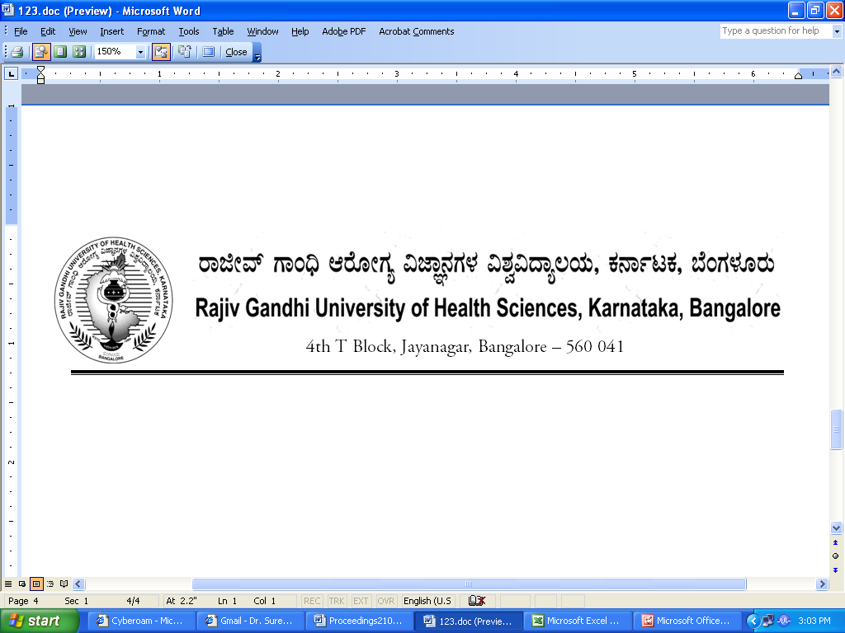

No. UA/ BOS- 13/2012-13 Dated 03.10.2012

NOTIFICATION

Sub: Reconstitution of Board of Studies in Homoeopathy (UG)
Ref: 1. This office Notification No. UA/BOS- 13 /2009-10 dated 31.7.2009
2. Minutes of the meeting of the 100th syndicate held on 28.8.2012

Pursuant to the decision of the syndicate in its meeting held on 28th August 2012, the Vice-Chancellor has been pleased to reconstitute the Board of Studies in Homoeopathy (UG) with the following members with effect from 31.07.2012 for a period of three years.

Chairman

Dr. Shivaprasad K
Vice Principal
Father Muller Homoeopathic Medical College
Deralakatte, Mangalore 575 108

Members

02 | Dr. Vivek Kulkarni  Professor,  AM Shaikh Homoeopathic Medical College, Nehrunagara,  Belgaum – 590010 | 03 | Dr. Satish Kumar  Principal,  Bhagawan Buddha  Homoeopathic Medical  College, Sreenidhi Complex,  Mallathahalli, Bangalore – 560056
04 | Dr. M. S. Rajapure  Principal,  Shivabasava Jyothi Homoeopathic Medical College, Ramnagar,  MM Extension, Belgaum – 590010 | 05 | Dr. Saeed Galpya  Professor,  AM Shaikh Homoeopathic Medical College, Nehrunagara,  Belgaum – 590010
06 | Dr. V Guruprasad  Professor,  Government Homoeopathic Medical College,  Siddaiah Puranik Road, Basaveshwar Nagar,  Bangalore – 560079 | 07 | Dr. Kiran Gaddi  Professor,  BD Jatti Homoeopathic Medical College, DC Compound,  Dharwar – 580001
08 | Dr. Kiran Sanikop  Professor,  Satya Sai Homoeopathic Medical College, Plot No. 19, PB Road, Sattur, Dharwar – 580009 | 09 | Dr. Lakshmi BS  Asst. Professor,  Government Homoeopathic Medical College, Siddaiah Puranik Road, Basaveshwar Nagar, Bangalore – 560079
10 | Dr. Shashi Kankanwadi  Principal,  SB Shirkoli Homoeopathic Medical College, Sankeshwar – 591313 | 11 | Dr. SYJ Quadri  Professor,  Alva’s Homoeopathic Medical College, Moodabidri – 574227
12 | Dr. Vijendra Itagi  Professor,  Alva’s Homoeopathic Medical College,  Moodabidri – 574227 | 13 | Dr. Renukanth Lokare  Professor,  HKE Society’s Homoeopathic Medical College, University Road, Gulbarga – 585105
14 | Dr. Satish Angadi  Assistant Professor  HKE Society’s Homoeopathic Medical College, University Road,  Gulbarga – 585105llege  and Hospital, Gulbarga | 15 | Dr. Srinath Rao  Principal  Father Muller Homoeopathic Medical College  Deralakatte, Mangalore 575 108

External Members

1 | Dr. Dharmendra Sharma  Principal,  DY Patil Homoeopathic Medical College, Pimpri, Pune - 411 018, Maharashtra State | 2 | Dr. S. D. Naik  Vice Principal,  Sri Kamakshi Devi Homoeopathic Medical College, Shiv Shail, Hill Top, Shiroda, Goa – 403103

By Order,

REGISTRAR

To
The Members Concerned

Copy to

- The Members of the Syndicate of RGUHS
- PA to Vice-Chancellor / Registrar / Registrar (Evaluation) / Finance Officer, RGUHS
- Director, Curriculum Development Cell / Public Information Officer / All officers of the University / RGUHS Website / Guard File / Office copy

No. UA/ BOS-14/2012-13 Dated 03.10.2012

NOTIFICATION

Sub: Reconstitution of Board of Studies in Homoeopathy (PG)
Ref: 1. This office Notification No. UA/BOS-14 /2009-10 dated 31.7.2009
2. Minutes of the meeting of the 100th syndicate held on 28.8.2012

Pursuant to the decision of the syndicate in its meeting held on 28th August 2012, the Vice-Chancellor has been pleased to reconstitute the Board of Studies in Homoeopathy (PG) with the following members with effect from 31.07.2012 for a period of three years.

Chairman

Dr. Shrikant Basawanni Konkani
Principal, Bharatesh Homoeopathic Medical College
Dharwar Road, Belgaum – 590 016

Members

02 | Dr. Madhav Kamath  Professor and PG Co-ordinator,  Fr. Muller Homoeopathic Medical College, Derlakatte,  Mangalore– 575108 | 03 | Dr. Sanjiv Pujar  Professor,  AM Shaikh Homoeopathic  Medical College, Nehru Nagar,  Belgaum – 590010
04 | Dr. Nahida Mulla  Principal  AM Shaikh Homoeopathic  Medical College, Nehru Nagar,  Belgaum – 590010 | 05 | Satish R. Kalashetty  Asst. Professor  HKE Society’s Homoeopathic Medical College, University Road, Gulbarga – 585105
06 | Dr. Mahadev Pasar  Professor,  HKE Society’s Homoeopathic Medical College, University Road, Gulbarga – 585105 | 07 | Dr. Anand Kulkarni  Principal,  BD Jatti Homoeopathic Medical College, DC Compound,  Dharwar – 580001
08 | Dr. Lingaraj Magdum  Asst. Professor and PG Co-ordinator,  Bharatesh Homoeopathic Medical College, Dharwar Road,  Belgaum – 590016 | 09 | Dr. Shreepad Hegde  Professor,  Government Homoeopathic Medical College, Siddaiah Puranik Road, Basaveshwar Nagar, Bangalore – 560079
10 | Dr. M. C. Hallikeri  Professor,  BD Jatti Homoeopathic Medical College, DC Compound,  Dharwar – 580001 | 11 | Dr. Jacintha Monteiro  Asst. Professor,  Father Muller Homoeopathic Medical College, Derlakatte, Mangalore– 575108
12 | Dr. S. M. D’Souza  Professor,  AM Shaikh Homoeopathic Medical College, Nehru Nagar,  Belgaum – 590010 | 13 | Dr. Deepa Varoor  Professor,  Bharatesh Homoeopathic Medical College, Dharwar Road,  Belgaum – 590016
14 | Dr. Sujatha Chougule  Professor  Bharatesh Homoeopathic Medical College, Dharwar Road,  Belgaum – 590016 | 15 | Dr. Usha S Rao  Professor  Government Homoeopathic Medical College, Siddaiah Puranik Road, Basaveshwar Nagar, Bangalore – 560079
`
External Members

1 | Dr. Arun Bhasme  Principal, SK Homoeopathic Medical College, Vidyanagar (East), Beed – 431122  (Maharashtra State) | 2 | Dr. Srinivasulu Gudugu  Asst. Professor, JSPS Homoeopathic Medical College, Ramanthapuram,  Hyderabad – 500013

By Order,

REGISTRAR

To
The Members Concerned

Copy to:

- The Members of the Syndicate of RGUHS
- PA to Vice-Chancellor / Registrar / Registrar (Evaluation) / Finance Officer, RGUHS
- Director, Curriculum Development Cell / Public Information Officer / All officers of the University / RGUHS Website / Guard File / Office copy

MEETING OF THE BOS IN HOMOEOPATHY (UG)
TO BE CONVEND ON 17/12/2012

 | Chairman
 | Dr. Shivaprasad K  Vice Principal  Father Muller Homoeopathic Medical College  Deralakatte, Mangalore 575 108 |  | Mobile No: 9343561455  E-Mail ID: shivaprasadk.sk@gmail.com  Signature:
 | Members
02 | Dr. Vivek Kulkarni  Professor,  AM Shaikh Homoeopathic Medical College, Nehrunagara,  Belgaum – 590010  Mobile No: 9845084701  E-Mail ID: dr.vivekkulkarni@yahoo.com  Signature: | 03 | Dr. Satish Kumar  Principal,  Bhagawan Buddha  Homoeopathic Medical  College, Sreenidhi Complex,  Mallathahalli, Bangalore – 560056  Mobile No: 9448227319/9845122787  E-Mail ID: satishkumar2k@yahoo.co.in  Signature:
04 | Dr. M. S. Rajapure  Principal,  Shivabasava Jyothi Homoeopathic Medical College, Ramnagar,  MM Extension, Belgaum – 590010  Mobile No: 9900967393  E-Mail ID: drrajapure@gmail.com  Signature: | 05 | Dr. Saeed Galpya  Professor,  AM Shaikh Homoeopathic Medical College, Nehrunagara,  Belgaum – 590010  Mobile No: 9448875528  E-Mail ID: saeed_ahmed123@rediffmail.com  Signature:
06 | Dr. V Guruprasad  Professor,  Government Homoeopathic Medical College,  Siddaiah Puranik Road, Basaveshwar Nagar,  Bangalore – 560079  Mobile No:  E-Mail ID:  Signature: | 07 | Dr. Kiran Gaddi  Professor,  BD Jatti Homoeopathic Medical College, DC Compound,  Dharwar – 580001  Mobile No: 9880252994  E-Mail ID: gaddikiran007@rediffmail.com  Signature:

08 | Dr. Kiran Sanikop  Professor,  Satya Sai Homoeopathic Medical College, Plot No. 19, PB Road, Sattur,  Dharwar – 580009  Mobile No: 9448760067  E-Mail ID: drksanikop@gmail.com  Signature: | 09 | Dr. Lakshmi BS  Asst. Professor,  Government Homoeopathic Medical College, Siddaiah Puranik Road, Basaveshwar Nagar, Bangalore – 560079  Mobile No: 9008281663  E-Mail ID: lakshmi.mahesha@gmail.com  Signature:
10 | Dr. Shashi Kankanwadi  Principal,  SB Shirkoli Homoeopathic Medical College, Sankeshwar – 591313  Mobile No:  E-Mail ID:  Signature: | 11 | Dr. Y.M.Qadri  Professor,  Alva’s Homoeopathic Medical College, Moodabidri – 574227  Mobile No: 9008047160  E-Mail ID: uwaitaucheed@rediffmail.com  Signature:
12 | Dr. Vijendra Itagi  Professor,  Alva’s Homoeopathic Medical College,  Moodabidri – 574227  Mobile No: 9448632600  E-Mail ID: vijay-itagi@yahoo.com  Signature: | 13 | Dr. Renukanth Lokare  Professor,  HKE Society’s Homoeopathic Medical College, University Road,  Gulbarga – 585105  Mobile No: 9036243946  E-Mail ID:  Signature:
14 | Dr. Satish Angadi  Assistant Professor  HKE Society’s Homoeopathic Medical College, University Road,  Gulbarga – 585105llege  Mobile No: 9449431838  E-Mail ID: dr_angadi@rediffmail.com  Signature:  and Hospital, Gulbarg | 15 | Dr. Srinath Rao  Principal  Father Muller Homoeopathic Medical College  Deralakatte, Mangalore 575 108  Mobile No: 9343569171  E-Mail ID: drsrinathrao@rediffmail.com  Signature:

External Members

1 | Dr. Dharmendra Sharma  Principal,  DY Patil Homoeopathic Medical College, Pimpri, Pune - 411 018, Maharashtra State  Mobile No: 9422330045/9822023993  E-Mail ID: drdbsharma@yahoo.com  Signature: | 2 | Dr. S. D. Naik  Principal,  Sri Kamakshi Devi Homoeopathic Medical College, Shiv Shail, Hill Top, Shiroda,  Goa – 403103  Mobile No: 09764264600  E-Mail ID: drsdnaik01@gmail.com  Signature:
MEETING OF THE BOS IN HOMOEOPATHY (PG)
TO BE CONVEND ON 17/12/2012

 | Chairman
 | Dr. Shrikant Basawanni Konkani  Principal, Bharatesh Homoeopathic Medical College  Dharwar Road,  Belgaum – 590 016 |  | Mobile No: 9845283242  E-Mail ID: drkonkani@rediffmail.com  Signature:
02 | Dr. Madhav Kamath  Professor and PG Co-ordinator,  Fr. Muller Homoeopathic Medical College, Derlakatte,  Mangalore– 575108  Mobile No:9448409624  E-Mail ID:drmvkamath@gmail.com  Signature: | 03 | Dr. Sanjiv Pujar  Professor,  AM Shaikh Homoeopathic  Medical College, Nehru Nagar,  Belgaum – 590010  Mobile No: 9341101195  E-Mail ID: drsspujar@yahoo.co.in  Signature:
04 | Dr. Nahida Mulla  Principal  AM Shaikh Homoeopathic  Medical College, Nehru Nagar,  Belgaum – 590010  Mobile No: 9448814660  E-Mail ID: drnahida.mulla@gmail.com  Signature: | 05 | Satish R. Kalashetty  Asst. Professor  HKE Society’s Homoeopathic Medical College, University Road, Gulbarga – 585105  Mobile No: 9844025215  E-Mail ID: drsatya@rediffmail.com  Signature:
06 | Dr. Mahadev Pasar  Professor,  HKE Society’s Homoeopathic Medical College, University Road, Gulbarga – 585105  Mobile No: 9449050504  E-Mail ID:  Signature: | 07 | Dr. Anand Kulkarni  Principal,  BD Jatti Homoeopathic Medical College, DC Compound,  Dharwar – 580001  Mobile No: 98445643211  E-Mail ID: dranandkulkarni@gmail.com  Signature:
08 | Dr. Lingaraj Magdum  Asst. Professor and PG Co-ordinator,  Bharatesh Homoeopathic Medical College, Dharwar Road,  Belgaum – 590016  Mobile No: 9901591449  E-Mail ID: drlingadum@rediffmail.com  Signature: | 09 | Dr. Shreepad Hegde  Professor,  Government Homoeopathic Medical College, Siddaiah Puranik Road, Basaveshwar Nagar,  Bangalore – 560079  Mobile No: 9448018654  E-Mail ID: drsreepad@rediffmail.com  Signature:
10 | Dr. M. C. Hallikeri  Professor,  BD Jatti Homoeopathic Medical College, DC Compound,  Dharwar – 580001  Mobile No: 0836-2444208  E-Mail ID: mchalikeri@rediffmail.com  Signature: | 11 | Dr. Jacintha Monteiro  Asst. Professor,  Father Muller Homoeopathic Medical College, Derlakatte, Mangalore– 575108  Mobile No: 9448155071  E-Mail ID: drjessym@yahoo.com  Signature:
12 | Dr. S. M. D’Souza  Professor,  AM Shaikh Homoeopathic Medical College, Nehru Nagar,  Belgaum – 590010  Mobile No: 9481679477  E-Mail ID: dr-samdsouza@yahoo.co.in  Signature: | 13 | Dr. Deepa Varoor  Professor,  Bharatesh Homoeopathic Medical College, Dharwar Road,  Belgaum – 590016  Mobile No: 09341019565  E-Mail ID: dr.deepa.varoor@gmail.com  Signature:
14 | Dr. Sujatha Chougule  Professor  Bharatesh Homoeopathic Medical College, Dharwar Road,  Belgaum – 590016  Mobile No: 9448542936  E-Mail ID: drsujac@yahoo.com  Signature: | 15 | Dr. Usha S Rao  Professor  Government Homoeopathic Medical College, Siddaiah Puranik Road, Basaveshwar Nagar, Bangalore – 560079  Mobile No:  E-Mail ID:  Signature:

External Members

1 | Dr. Arun Bhasme  Principal, SK Homoeopathic Medical College, Vidyanagar (East), Beed – 431122  (Maharashtra State)  Mobile No:  E-Mail ID:  Signature: | 2 | Dr. Srinivasulu Gudugu  Asst. Professor, JSPS Homoeopathic Medical College, Ramanthapuram,  Hyderabad – 500013  Mobile No: 9440203747  E-Mail ID: srinivasalugadugu@gmail.com  Signature:

