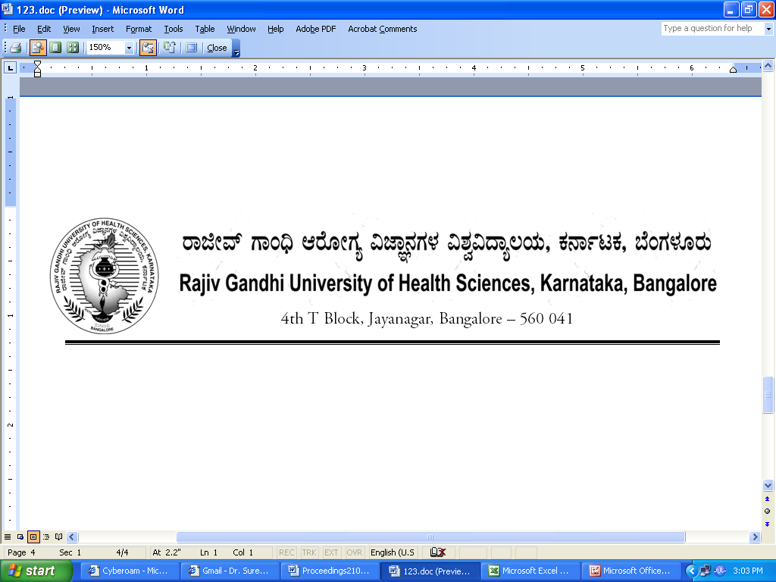

No. UA/BOS-7/2012-13 Date: 03.10.2012

NOTIFICATION

Sub: Reconstitution of Board of Studies in Dental (UG)
Ref: 1. This office Notification No. UA/BOS-07/2009-10 dated 31.7.2009
2. Minutes of the Meeting of the 100th Syndicate held on 28.8.2012

Pursuant to the decision of the Syndicate in its meeting held on 28th August 2012, the Vice Chancellor has been pleased to reconstitute the Board of Studies in Dental (UG) with the following members with effect from 31.07.2012 for a period of three years.

Chairman

Dr.Girish B Giraddi
Professor and Head,
Department of Oral and Maxillofacial Surgery
Government Dental College
Bangalore

Members

02 | Dr. Lakshmikanth,  Professor of Orthodontics,  AECS Maaruti College of Dental Sciences & Research Centre, 108, Hulimavu Tank Bund Road,  BTM 6th Stage, 1st Phase, Kammanahalli, Off Bannerghatta Road, Bangalore - 560 076 | 03 | Dr. Vasanth Kumar M,  Prof. of Prosthodontics &  Principal  KGF College of Dental Sciences  No. 36, Temple Road  BEML Nagar, KGF
04 | Dr. Krishna Prasad  Professor of Endodontics  K V G Dental College & Hospital  Kurunji Bhag, Dakshina Kannada, Sullia 574 327 | 05 | Dr. Hemalatha  Professor of Periodontics &  Principal  M R Ambedkar Dental College & Hospital  1/36, Clive Road, Cooke Town, Bangalore 560 005,
06 | Dr. Tarun,  Professor of Periodontics,  Bapuji Dental College & Hospital,  DAVANGERE - 577 004 | 07 | Dr. Kodandaiah,  Professor of Oral Medicine,  S J M College of Dental Sciences,  P. B. Road, Chitradurga 577 501
08 | Dr. Veerendra Kumar  Prof. of Oral Pathology  D A Pandu Memorial R V Dental  College and Hospital  CA-37, 24th Main, I Phase  J.P.Nagar Bangalore – 78 | 09 | Dr. D P Narayan,  Principal,  Professor & Head, department of Public Health Dentistry,  Vydehi Institute of Dental Sciences & Research Centre,  82, EPIP Area,  Whitefield,Bangalore - 560066
10 | Dr. Shilpa Shetty  Professor of Prosthodontics,  V S Dental College & Hospital  Vokkaligara Sanga Dental College & Hospital  K.R. Road, VV Puram,  Bangalore 560 004 | 11 | Dr. Kumar  Professor of Paedodontics,  AECS Maaruti College of Dental Sciences & Research Centre, 108, Hulimavu Tank Bund Road,  BTM 6th Stage, 1st Phase, Kammanahalli, Off Bannerghatta Road, Bangalore - 560 076
12 | Dr. Satish Patil  Professor of Oral & Maxillofacial  Surgery,  HKE’s Nijalingappa Institute of  Dental Sciences,  Sedam Road, Gulbarga - 585 105 | 13 | Dr. Pavithra,  Professor of Orthodontics,  Sri Hasanamba Dental College &  Hospital  P.B . No. 86, Vidyanagar,  Ha Hassan 573 201
14 | Dr. B R Ahmed Mujib  Professor of Oral Pathology  Bapuji Dental College & Hospital,  DAVANGERE – 577 004 | 15 | Dr. Sharath Chandra Shetty  Professor & HOD  Dept., of Orthodontics  KVG Dental College,  K V G Dental College & Hospital  Kurunji Bhag, Dakshina Kannada, Sullia 574 327

External Members

1 | Dr. Ragini  Prof. & HOD of Orthodontics  & Principal  Jamia Milia Islamia University  Dental College  New Delhi | 2 | Dr. V Rangarajan  Prof. of Prosthodontics &  Vice Principal  Sri Venkateswara Dental College & Hospital  Off.Old Mahabalipuram Road  Near Navalur  Thalambur, Chennai - 603 103

By Order,

REGISTRAR

To
The Members Concerned

Copy to
- The Members of the Syndicate of RGUHS
- PA to Vice-Chancellor / Registrar / Registrar (Evaluation) / Finance Officer, RGUHS
- Director, Curriculum Development Cell / Public Information Officer / All officers of the University / RGUHS Website / Guard File / Office copy

No. UA/ BOS-8/2012-13 Date: 03.10.2012

NOTIFICATION

Sub: Reconstitution of Board of Studies in Dental (PG)
Ref: 1. This office Notification No. UA/BOS-08/2009-10 dated 31.7.2009
2. Minutes of the meeting of the 100th syndicate held on 28.8.2012

Pursuant to the decision of the syndicate in its meeting held on 28th August 2012, the Vice-Chancellor has been pleased to reconstitute the Board of Studies in Dental (PG) with the following members with effect from 31.07.2012 for a period of three years.

Chairman

Dr. Balaram D Naik
Prof. & HOD of Conservative
Dentistry & Endodontics,
SDM College of
Dental Sciences & Hospital
Sattur, Dharwad - 580 009

02 | Dr. C S Ramachandra  Professor of Orthodontics and Principal,  AECS Maaruti College of Dental Sciences & Research Centre, 108, Hulimavu Tank Bund Road,  BTM 6th Stage, 1st Phase, Kammanahalli, Off Bannerghatta Road, Bangalore - 560 076 | 03 | Dr. Roopa R Nadig,,  Prof. & HOD of Conservative  Dentistry & Endodontics,  Dayanand Sagar College of  Dental Sciences, Shavige  Malleshwara Hills, Kumaraswamy  Layout, Bangalore 560 078
04 | Dr. Girish Rao S,  Professor & Head, Dept., of  Oral and Maxillofacial Surgery  D A Pandu Memorial R V Dental  College and Hospital  CA-37, 24th Main, I Phase  J.P.Nagar Bangalore – 78 | 05 | Dr. Prakash Chandra  Professor of Paedodontics,  M S Ramaiah Dental College & Hospital  MSRIT Post M S Ramaiah Nagar, Mathikere, Bangalore 560 054
06 | Dr. H L Jayakumar,  Professor & Head of  Preventive & Community Dentistry  AECS Maaruti College of Dental Sciences & Research Centre, 108, Hulimavu Tank Bund Road,  BTM 6th Stage, 1st Phase, Kammanahalli, Off Bannerghatta Road, Bangalore - 560 076 | 07 | Dr. B V Sreenivasa Murthy,  Prof. of Endodontics & Principal,  M S Ramaiah Dental College & Hospital  MSRIT Post M S Ramaiah Nagar, Mathikere, Bangalore 560 054
08 | Dr. Prithviraj D R  Prof. & Head of Prosthodontics &  Principal  Government Dental College  Bangalore | 09 | Dr. Ramakanth Nayak,  Professor of Oral Pathology &  Principal,  Maratha Mandal's Nathajirao G. Halgekar Institute of Dental Sciences & Research Centre.  # 47 A/2, Near KSRP Ground,  Bauxite Road, Belgaum-10
10 | Dr. Surekha R Puranik  Professor of Oral Medicine  P M Nadagowda Memorial  Dental College & Hospital  Bagalkot 587 101 | 11 | Dr. Jayashree Mudda  Professor of Periodontics &  Principal  HKE’s Nijalingappa Institute of  Dental Sciences,  Sedam Road, Gulbarga - 585 105
12 | Dr. Ramesh,  Professor of Oral Medicine &  Principal  Navodaya Dental College,  Mantralayam Road  Post Box 26, Raichur 584 103 | 13 | Dr. Dinesh  Prof. of Orthodontics & Principal  D A Pandu Memorial R V Dental  College and Hospital  CA-37, 24th Main, I Phase  J.P.Nagar Bangalore – 78
14 | Dr. R Dilip Kumar  Professor & HOD of Oral &  Maxillofacial Surgery,  Dayanand Sagar College of  Dental Sciences, Shavige  Malleshwara Hills, Kumaraswamy  Layout, Bangalore 560 078 | 15 | Dr. Ravindra Savadi,  Professor of Prosthodontics,  The Oxford Dental College  10th Milestone,Bommanahalli, Hosur road, Bangalore 560068

External Members

1 | Dr. K Harsha Kumar  Professor of Prosthodontics  Government Dental College  Medical College PO  Thiruvanathapuram  Kerala, PIN-695011 | 2 | Dr. Murali Mohan  Professor of Endodontics &  Principal  Government Dental College,  Gunadala, Vijaywada 520001  Andhrapradesh

By Order,

REGISTRAR

To
The Members Concerned

Copy to
- The Members of the Syndicate of RGUHS
- PA to Vice-Chancellor / Registrar / Registrar (Evaluation) / Finance Officer, RGUHS
- Director, Curriculum Development Cell / Public Information Officer / All officers of the University / RGUHS Website / Guard File / Office copy

MEETING OF THE BOS IN DENTAL (UG)
TO BE CONVEND ON 06/12/2012

 | Chairman
 | Dr.Girish B Giraddi  Professor and Head,  Department of Oral and Maxillofacial Surgery  Government Dental College  Bangalore |  | Mobile No: 9740098199  E-Mail ID: girishgiraddi@gmail.com  Signature:
 | Members
02 | Dr. Lakshmikanth,  Professor of Orthodontics,  AECS Maaruti College of Dental Sciences & Research Centre, 108, Hulimavu Tank Bund Road,  BTM 6th Stage, 1st Phase, Kammanahalli, Off Bannerghatta Road,  Bangalore - 560 076  Mobile No: 9844093035  E-Mail ID: laxmikanthsm72@yahoo.co.in  Signature: | 03 | Dr. Vasanth Kumar M,  Prof. of Prosthodontics &  Principal  KGF College of Dental Sciences  No. 36, Temple Road  BEML Nagar, KGF  Mobile No: 9845211413  E-Mail ID: vasanth_kb@yahoo.co.in  Signature:
04 | Dr. Krishna Prasad  Professor of Endodontics  K V G Dental College & Hospital  Kurunji Bhag, Dakshina Kannada,  Sullia 574 327  Mobile No:  E-Mail ID:  Signature: | 05 | Dr. Hemalatha  Professor of Periodontics &  Principal  M R Ambedkar Dental College & Hospital  1/36, Clive Road, Cooke Town, Bangalore 560 005,  Mobile No: 9845034880  E-Mail ID: drhemalata@yahoo.com  Signature:
06 | Dr. Tarun,  Professor of Periodontics,  Bapuji Dental College & Hospital,  DAVANGERE - 577 004  Mobile No: 9886210507  E-Mail ID: tarundental@gmail.com  Signature: | 07 | Dr. Kodhandurama.G.S.  Professor of Oral Medicine,  S J M College of Dental Sciences,  P. B. Road, Chitradurga 577 501  Mobile No: 9342310665  E-Mail ID:kodandarama@yahoo.com  Signature:
08 | Dr. Veerendra Kumar  Prof. of Oral Pathology  D A Pandu Memorial R V Dental  College and Hospital  CA-37, 24th Main, I Phase  J.P.Nagar Bangalore – 78  Mobile No: 9341215303  E-Mail ID: drveeru@yahoo.com  Signature: | 09 | Dr. D P Narayan,  Principal  Professor of Community Dentistry, Vydehi Dental College, Bangalore  82, EPIP Area,  Whitefield  Bangalore 560066  Mobile No: 9591508650  E-Mail ID: dr_dpnarayan@yahoo.in  Signature:
10 | Dr. Shilpa Shetty  Professor of Prosthodontics,  V S Dental College & Hospital  Vokkaligara Sanga Dental College & Hospital  K.R. Road, VV Puram,  Bangalore 560 004  Mobile No: 9448061370  E-Mail ID: drshilpashetty@gmail.com  Signature: | 11 | Dr. Kumar  Professor of Paedodontics,  AECS Maaruti College of Dental Sciences & Research Centre, 108, Hulimavu Tank Bund Road,BTM 6th Stage, 1st Phase, Kammanahalli, Off Bannerghatta Road, Bangalore - 560 076  Mobile No: 9845017585  E-Mail ID: nckumar73@gmail.com  Signature:
12 | Dr. Satish Patil  Professor of Oral & Maxillofacial  Surgery,  HKE’s Nijalingappa Institute of  Dental Sciences,  Sedam Road, Gulbarga - 585 105  Mobile No: 9448124464  E-Mail ID: satpat71@gmail.com  Signature: | 13 | Dr. Pavithra,  Professor of Orthodontics,  Sri Hasanamba Dental College &  Hospital, P.B . No. 86, Vidyanagar,  Ha Hassan 573 201  Mobile No: 9845014454  E-Mail ID: drpavius@yahoo.co.in  Signature:
14 | Dr. B R Ahmed Mujib  Professor of Oral Pathology  Bapuji Dental College & Hospital,  DAVANGERE – 577 004  Mobile No: 9448948124  E-Mail ID: mujib512@yaoo.com  Signature: | 15 | Dr. Sharath.K.Shetty  Professor & HOD  Dept., of Orthodontics  KVG Dental College, K V G Dental College & Hospital,Kurunji Bhag, Dakshina Kannada,  Sullia 574 327  Mobile No: 9448300500  E-Mail ID: drsharathshetty45@gmail.com  Signature:

External Members

1 | Dr. Ragini  Prof. & HOD of Orthodontics  & Principal  Jamia Milia Islamia University  Dental College  New Delhi  Mobile No: 9810881259  E-Mail ID: drragini52@gmail.com  Signature: | 2 | Dr. V Rangarajan  Prof. of Prosthodontics &  Vice Principal  Sri Venkateswara Dental College & Hospital,Off.Old Mahabalipuram Road  Near Navalur,Thalambur,  Chennai - 603 103  Mobile No:  E-Mail ID:  Signature:

