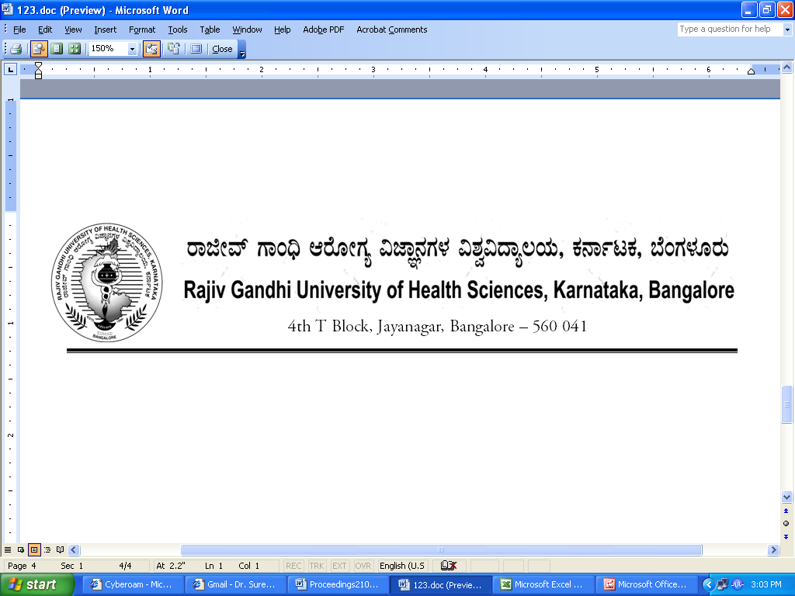
No. UA/ BOS- 17/2012-13 Dated 03.10.2012

NOTIFICATION

Sub: Reconstitution of Board of Studies in Allied Health Sciences
Ref: 1. This office Notification No. UA/BOS-16/2009-10 dated 31.7.2009
2. Minutes of the meeting of the 100th syndicate held on 28.8.2012

Pursuant to the decision of the syndicate in its meeting held on 28th August 2012, the Vice-Chancellor has been pleased to reconstitute the Board of Studies in Allied Health Sciences with the following members with effect from 31.07.2012 for a period of three years.

Chairperson

Ms. Reshma Lobo
Principal,
Padmashree College of Hospital Administration
No. 23, Sri Gurukrupa Layout,
80 Ft. Road, Nagarbhavi,
Bangalore – 560072

Members

02 | Dr. Arun Kumar  Dept. of Biochemistry  Fr.Muller's Medical College  P.B.No.501, Fr.Muller's Road,  Kankanady, Mangalore - 575 002 | 03 | Dr.P.K.Dash  Prof. & HoD  Cardiac Care  Sri Sathya Sai Institute of Higher Medical Sciences, (B.Sc. Cardiac Care Technology), Whitefield, Bangalore.
04 | Mr. Alwin Joseph Lewis  Professor of Microbiology  Alva’s College of Medical Laboratory Technology  Moodbidri, South Canara 574 227 | 05 | Usha S.Shetty  Principal  City College of MLT  A Unity of City Hospital Charitable Trust, Pound garden, kadri, Mangalore
06 | Dr. S.U. Zulfikar Ahmed  Asst. Professor, Dept. of Pathology  A J Institute Of Medical Sciences,  Kuntikana, NH 17  Mangalore 575 004 | 07 | Mr. Ramachandra V Shet  Dept., of Optometry  Netradhama Superspecialty  Eye Hospital,  # 256/14, Kanakapura Main Road,  7th Block, Jayanagar,  Bangalore-560 082.
08 | Ms. Ritu Ghosh  Prosthetist & Orthotist,  Deputy Director-Training Mobility India,  1st & 1st ‘A’ Cross, 2nd Phase,  J. P. Nagar, Bangalore – 560078 | 09 | Dr. T N Raghunath  Director  Allied Health Science Courses  Narayana Hrudayalaya  Bangalore
10 | Dr. S V Suresh Babu  Principal  Padmashree Institute of Clinical Research  No. 23, Sri Gurukrupa Layout,  80 Ft. Road, Nagarbhavi,  Bangalore – 560072 | 11 | Pratijna Suhasini G. R  Principal  M V Shetty Institute of Health Sciences (MLT)  Vidyanagar Panjimoguru Post  Mangalore 575 013
12 | Dr.Santosh Mulge  Asst. Professor, Dept. of Anatomy  Raichur Institute of Medical Sciences,  Sy. No. 307 & 308,, Hyderabad Road, Raichur - 584102 | 13 | Dr. Harish Rao  Asso. Prof.  Dept. of Biochemistry,  Vijayanagar Institute Of Medical Sciences,  Cantonment, Bellary - 583 104
14 | Dr. Geraldine Menezes  Asso. Professor,  Dept. of Biochemistry  St. Johns Medical College,  Sarjapur Road, Bangalore. | 15 | K Basheer Ahamed  Professor, Dept. of Biochemistry  Al-Ameen Medical College  Athani Road, Bijapur

External Members

1 | Dr.Vishwa Saralayya  Asso. Professor  Dept. of Microbiology  Kasturba Medical College  Mangalore | 2 | Dr. Sumitra Suldhana  Asso. Prof.  Dept. of Hospital Administration  Yenepoya University  Mangalore

By Order,

REGISTRAR

To
The Members Concerned

Copy to:
- The Members of the Syndicate of RGUHS
- PA to Vice-Chancellor / Registrar / Registrar (Evaluation) / Finance Officer, RGUHS
- Director, Curriculum Development Cell / Public Information Officer / All officers of the University / RGUHS Website / Guard File / Office copy

Chairperson
Ms. Reshma Lobo
Principal,
Padmashree College of Hospital Administration
No. 23, Sri Gurukrupa Layout,
80 Ft. Road, Nagarbhavi,
Bangalore – 560072
Members
02 | Dr. Arun Kumar  Dept. of Biochemistry  Fr.Muller's Medical College  P.B.No.501, Fr.Muller's Road,  Kankanady, Mangalore - 575 002 | 03 | Dr.P.K.Dash  Prof. & HoD  Cardiac Care  Sri Sathya Sai Institute of Higher Medical Sciences, (B.Sc. Cardiac Care Technology), Whitefield, Bangalore.
04 | Mr. Alwin Joseph Lewis  Professor of Microbiology  Alva’s College of Medical Laboratory Technology  Moodbidri, South Canara 574 227 | 05 | Usha S.Shetty  Principal  City College of MLT  A Unity of City Hospital Charitable Trust, Pound garden, kadri, Mangalore
06 | Dr. S.U. Zulfikar Ahmed  Asst. Professor, Dept. of Pathology  A J Institute Of Medical Sciences,  Kuntikana, NH 17  Mangalore 575 004 | 07 | Mr. Ramachandra V Shet  Dept., of Optometry  Netradhama Superspecialty  Eye Hospital,  # 256/14, Kanakapura Main Road,  7th Block, Jayanagar,  Bangalore-560 082.
08 | Ms. Ritu Ghosh  Prosthetist & Orthotist,  Deputy Director-Training Mobility India,  1st & 1st ‘A’ Cross, 2nd Phase,  J. P. Nagar, Bangalore – 560078 | 09 | Dr.T.N.Raghunath  Director  Allied Health Sciences Courses  Narayana Hrudayalaya  Bangalore
10 | Dr. S V Suresh Babu  Principal  Padmashree Institute of Clinical Research  No. 23, Sri Gurukrupa Layout,  80 Ft. Road, Nagarbhavi,  Bangalore – 560072 | 11 | Pratijna Suhasini G. R  Principal  M V Shetty Institute of Health Sciences (MLT)  Vidyanagar Panjimoguru Post  Mangalore 575 013
12 | Dr.Santosh Mulge  Asst. Professor, Dept. of Anatomy  Raichur Institute of Medical Sciences,  Sy. No. 307 & 308,, Hyderabad Road, Raichur - 584102 | 13 | Dr. Harish Rao  Asso. Prof.  Dept. of Biochemistry,  Vijayanagar Institute Of Medical Sciences,  Cantonment, Bellary - 583 104
14 | Dr. Geraldine Menezes  Asso. Professor,  Dept. of Biochemistry  St. Johns Medical College,  Sarjapur Road, Bangalore. | 15 | K Basheer Ahamed  Professor, Dept. of Biochemistry  Al-Ameen Medical College  Athani Road, Bijapur
External Members
1 | Dr.Vishwa Saralayya  Asso. Professor  Dept. of Microbiology  Kasturba Medical College  Mangalore | 2 | Dr. Sumitra Suldhana  Asso. Prof.  Dept. of Hospital Administration  Yenepoya University  Mangalore

