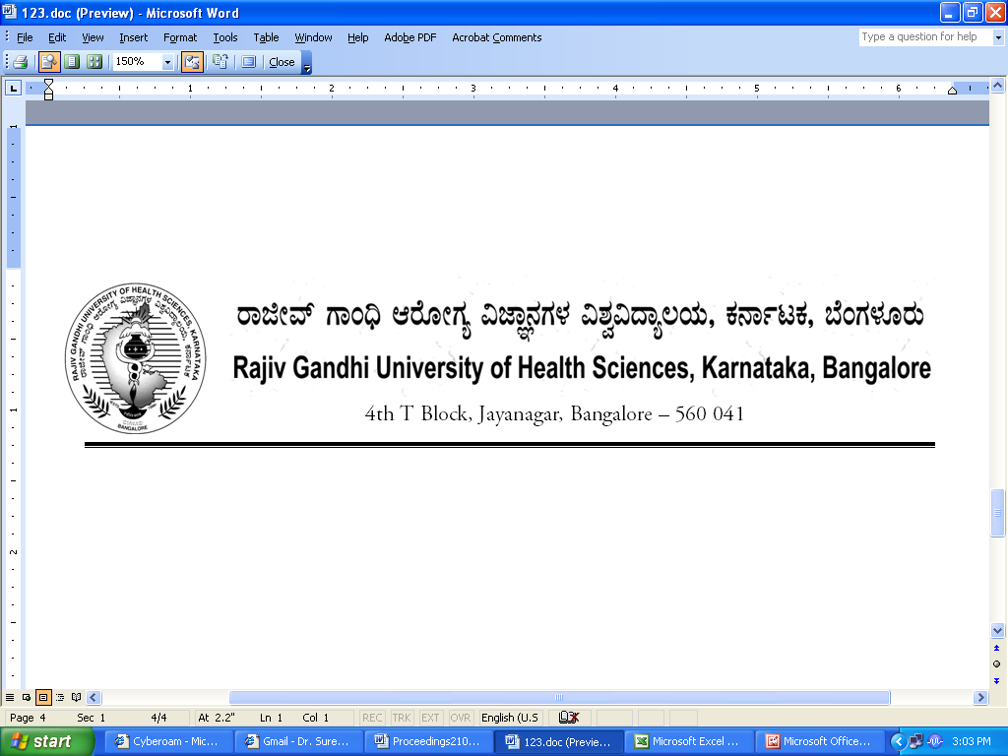

No. UA/ BOS- 15/2012-13 Date:03.10.2012

NOTIFICATION

Sub: Reconstitution of Board of Studies in Ayurveda (UG)
Ref: 1. This office Notification No. UA/BOS- 15 /2009-10 dated 31.7.2009
2. Minutes of the meeting of the 100th syndicate held on 28.8.2012

Pursuant to the decision of the syndicate in its meeting held on 28th August 2012, the Vice-Chancellor has been pleased to reconstitute the Board of Studies in Ayurveda (UG) with the following members with effect from 31.07.2012 for a period of three years.

Chairman

Dr. Gajanana Hegde
Prof. & HOD of Kayachikitsa
Government Ayurvedic Medical College,
Sayyaji Rao Road, Vishweshwaraiah Circle
Mysore 570 021

Members

02 | Dr. Allama Prabhu  Prof. of Rasashastra  Shri. Hingulambika Education Society Ayurved College Sidramrao Astikar Marg, Bhavani Nagar, Maktampura, Gulbarga. | 03 | Dr. B R Ramakrishna  Principal & Professor of Dravyaguna Vignana  Sushrutha Ayurveda Medical College, No.23, Papaiah Garden, Diagonal Road, C K Achukattu, BSK III Stage, Bangalore - 85
04 | Dr. Madhavadiggavi  Prof. of Kaya Chikitsa  Pandit Taranath Government Ayurvedic Medical College, Ananthapur Road, Bellary- 583 101 | 05 | Dr. C Thayagaraja  Prof. of Shalyatantra  Ayurveda Maha Vidyalaya  Heggeri Extension  Karwar Road, Hubli 580 024
06 | Dr. Hulikatti  Professor in Ayurveda Itihasa  Sindagi Shantaveereswar Ayurvedic Medical College  Haveri | 07 | Dr. Basavaraj Savadi  Principal  Koppal Ayurveda Medical College  Koppal
08 | Dr. Umesh C  Asst. Prof. of Kayachikitsa  Sri Sri College of Ayurvedic Science and Research  21st km , P. O. Udayapura,  Kanakapura Road, Bangalore -82 | 09 | Dr. Subbanna Gowda  Professor of Kayachikitsa  Ayurvedic Medical College,  Hubli
10 | Dr. B.S.Sreedhar  Professor of Panchakarma  Government Ayurveda Medical college, Dhanvantri Road,  Bangalore 560009 | 11 | Dr. Ganesh Prasad  Asst. Professor  SDM College of Naturopathy and Yogic Sciences, Ujre
12 | Dr. Shobha Hiremath  Prof. of Rasashastra & Bhaishajya Kalpana  Government Ayurvedic Medical College, Dhanvantri Road, Bangalore 560009 | 13 | Dr. M R Kulkarni  Professor & H.O.D.of Streeroga and Prasooti Tantra  Shushrutha Ayurvedic Medical College  Bangalore
14 | Dr. Ajay M R  Asst. Prof. of Vikruti Vignana  Sushrutha Ayurveda Medical College  No.23, Papaiah Garden, Diagonal Road, C K Achukattu, BSK III Stage, Bangalore - 560 085 | 15 | Dr. B B Hunagund  Professor of Shareera Rachana  Ayurveda Mahavidyalaya  Heggeri Extension  Karwar Road, Hubli 580 024

External Members

1 | Dr. Prankush Rao  Prof. of Dravyaguna  Government Ayurveda College  Tirupathi | 2 | Dr. A R V Murthy  Principal  Charutharvidya Mandal’s Govind Bhai Jorashai Ayurveda Medical College,  New Vallabh Vidyanagar, Anand  Gujarat

By Order,

Sd/-
REGISTRAR

To
The Members Concerned

Copy to
- The Members of the Syndicate of RGUHS
- PA to Vice-Chancellor / Registrar / Registrar (Evaluation) / Finance Officer, RGUHS
- Director, Curriculum Development Cell / Public Information Officer / All officers of the University / RGUHS Website / Guard File / Office copy

No. UA/ BOS-16/2012-13 Date:03.10.2012

NOTIFICATION

Sub: Reconstitution of Board of Studies in Ayurveda (PG)
Ref: 1. This office Notification No. UA/BOS-17/2009-10 dated 31.7.2009
2. Minutes of the meeting of the 83rd syndicate held on 28.8.2012

Pursuant to the decision of the syndicate in its meeting held on 28th August 2012, the Vice-Chancellor has been pleased to reconstitute the Board of Studies in Ayurveda (PG) with the following members with effect from 31.07.2012 for a period of three years.

Chairman

Dr. R. Vijayasarathy
Prof. & Head
Government Ayurveda Medical College
Dhanvantri Road,
Bangalore-560009

Members

02 | Dr. Siddaiah Aradhyamath  Professor in Shalyatantra  JSS Ayurvedic Medical College,  Sri Shivarathreshwara Nagar,  Mysore 570 015 | 03 | Dr. Ahalya Sharma  Asst. Prof. of Shalya Tantra  Government Ayurvedic Medical College, Dhanvantri Road,  Bangalore-560009
04 | Dr. B V Prasanna  Professor of Roga Nirodha  SDM Ayurveda College  Laxminarayan Nagar, P.O. Kuthpady, Udupi Tq.,  Kuthpady - 574 118 | 05 | Dr.Shivprasad  Dean,  SDM College of Naturopathy and Yogic Sciences, Ujre
06 | Dr. Jayakrishna Nayak  Professor of Shalyatantra  SDM Ayurveda College  Laxminarayan Nagar, P.O. Kuthpady, Udupi Tq.,  Kuthpady - 574 118 | 07 | Dr. Ramachandra Nesargi  Assoc. Prof. of Panchakarma  JSS Ayurvedic Medical College,  Sri Shivarathreshwara Nagar,  Mysore 570 015
08 | Dr. B. Vinay Chandra Shetty  Prof. of Rasashastra & Principal  Alva’s Ayurvedic Medical College  Moodbidri | 09 | Dr. Kavitha M B  Asso. Prof. of Shwasthavratha  SDM Ayurvedic Medical College  P.B. No.164, B M Road, Thanniruhalla, Hassan - 573 201
10 | Dr. Vishwas Kulkarni  Professor of Shalyatantra  Muniyal Institute of Ayurveda Medical Sciences, Manipal | 11 | Dr. Kiran Goud,  Principal,  Kalabyraveshwar Ayurvedic Medical College,  No.10, Pipe Line Road,, R P C layout, Vijayanagar,  Bangalore - 560 040
12 | Dr. Aruna,  Professor of Kayachikitsa  JSS Ayurveda Medical College  Mysore - 570 015 | 13 | Dr. N S Shetter,  Principal,  K V G Ayurvedic Medical College, Ambatedka, Kurunjibagh,  Sullia - 574 327
14 | Dr. Chandrakant Halli,  Assistant Professor,  Sri N K Jabshetty Ayurvedic Medical College,  Shri Sidharudh Math,  Bidar-585 403 | 15 | Dr. Laxman V Aramani,  Professor and Principal,  SCSES Dhanawantari Ayurvedic Medical College, Hospital and Research Centre,  Nipani

External Members

1 | Dr. Hemanth Joshi Khane  Prof. of Shalyatantra  (KLE University)  Sri BM Kanakanawadi Ayurveda Mahavidyalaya, Belgaum | 2 | Dr. T Sree Kumar  Prof. of Kriya shareera  Vaidyaratnam Ayurveda College  Ollur, Thrissur, Kerala

By Order,

REGISTRAR

To
The Members Concerned

Copy to
- The Members of the Syndicate of RGUHS
- PA to Vice-Chancellor / Registrar / Registrar (Evaluation) / Finance Officer, RGUHS
- Director, Curriculum Development Cell / Public Information Officer / All officers of the University / RGUHS Website / Guard File / Office copy

MEETING OF THE BOS IN AYURVEDA (UG)
TO BE CONVEND ON 06/12/2012

 | Chairman
 | Dr. Gajanana Hegde  Prof. & HOD of Kayachikitsa  Government Ayurvedic Medical College,  Sayyaji Rao Road, Vishweshwaraiah Circle  Mysore 570 021 |  | Mobile No: 9448738938  E-Mail ID:suhas.hegde75@gmail.com  Signature:
 | Members
02 | Dr. Allama Prabhu  Prof. of Rasashastra  Shri. Hingulambika Education Society Ayurved College Sidramrao Astikar Marg, Bhavani Nagar, Maktampura, Gulbarga.  Mobile No: 9844165021  E-Mail ID: susmitha_slb@gmail  Signature: | 03 | Dr. B R Ramakrishna  Principal & Professor of Dravyaguna Vignana  Sushrutha Ayurveda Medical College, No.23, Papaiah Garden, Diagonal Road, C K Achukattu, BSK III Stage, Bangalore – 85  Mobile No:  E-Mail ID:  Signature:
04 | Dr. Madhavadiggavi  Prof. of Kaya Chikitsa  Pandit Taranath Government Ayurvedic Medical College, Ananthapur Road,  Bellary- 583 101  Mobile No: 9844094290  E-Mail ID: drmvdblx@gmail.com  Signature: | 05 | Dr. C Thayagaraja  Prof. of Shalyatantra  Ayurveda Maha Vidyalaya  Heggeri Extension  Karwar Road, Hubli 580 024  Mobile No: 9886245072  E-Mail ID:drctraja@gmail.com  Signature:
06 | Dr. Hulikatti.G.B  Professor in Ayurveda Itihasa  Sindagi Shantaveereswar Ayurvedic Medical College  Haveri  Mobile No: 9449122030  E-Mail ID:  Signature: | 07 | Dr. Basavaraj Savadi  Principal  Koppal Ayurveda Medical College  Koppal  Mobile No: 9845646885  E-Mail ID: Savadi.savitha@gmail  Signature:
08 | Dr. Umesh C  Asst. Prof. of Kayachikitsa  Sri Sri College of Ayurvedic Science and Research,21st km , P. O. Udayapura,  Kanakapura Road, Bangalore -82  Mobile No: 9844145295  E-Mail ID: drumeshau@gmail.com  Signature: | 09 | Dr. Subbanna Gowda  Professor of Kayachikitsa  Ayurvedic Medical College,  Hubli  Mobile No: 9448543780  E-Mail ID: ayurpgs77@gmail.com  Signature:
10 | Dr. B.S.Sreedhar  Professor of Panchakarma  Government Ayurveda Medical college, Dhanvantri Road,  Bangalore 560009  Mobile No:  E-Mail ID:  Signature: | 11 | Dr. Ganesh Prasad  Asst. Professor  SDM College of Naturopathy and Yogic Sciences, Ujre  Mobile No:  E-Mail ID:  Signature:
12 | Dr. Shobha Hiremath  Prof. of Rasashastra & Bhaishajya Kalpana  Government Ayurvedic Medical College, Dhanvantri Road, Bangalore 560009  Mobile No: 9449588472  E-Mail ID:drshobha_gh@rediffmail.com  Signature: | 13 | Dr. M R Kulkarni  Professor & H.O.D.of Streeroga and Prasooti Tantra  Shushrutha Ayurvedic Medical College  Bangalore  Mobile No: 9480546478  E-Mail ID: drkulkarnimr@rediffmal.com  Signature:
14 | Dr. Ajay M R  Asst. Prof. of Vikruti Vignana  Sushrutha Ayurveda Medical College  No.23, Papaiah Garden, Diagonal Road, C K Achukattu, BSK III Stage,  Bangalore - 560 085  Mobile No: 9902536999  E-Mail ID: ajay.mr@gmai.com  Signature: | 15 | Dr. B B Hunagund  Professor of Shareera Rachana  Ayurveda Mahavidyalaya  Heggeri Extension  Karwar Road, Hubli 580 024  Mobile No: 9448775052  E-Mail ID:  Signature:

External Members

1 | Dr. Prankush Rao  Prof. of Dravyaguna  Government Ayurveda College  Tirupathi  Mobile No:  E-Mail ID:  Signature: | 2 | Dr. A R V Murthy  Principal  Charutharvidya Mandal’s Govind Bhai Jorashai Ayurveda Medical College,  New Vallabh Vidyanagar, Anand  Gujarat  Mobile No:  E-Mail ID:  Signature:

